***Documentation: Pilot Social Audits under Meghalaya Community Participation and Public Service Social Audit Act, 2017***

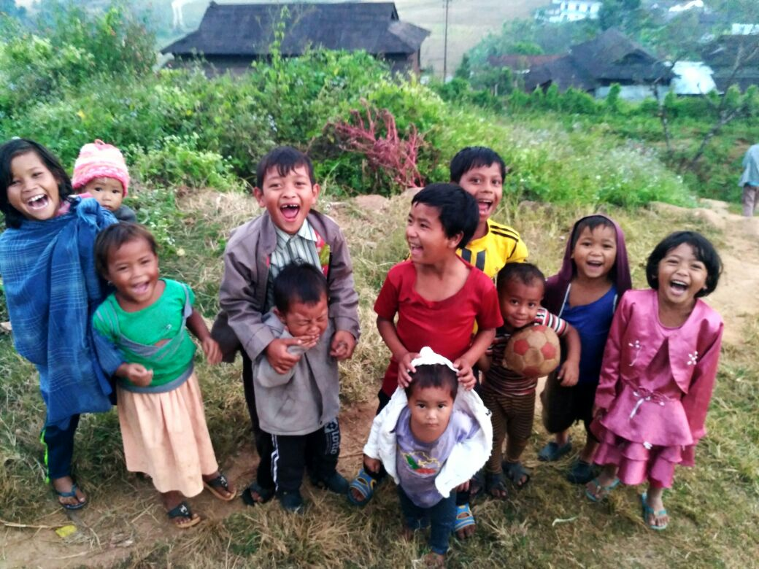

***(September-December 2017)***

The pilot social audits undertaken in Meghalaya from October-December 2017 has been an experience that has contributed to the deeper understanding of the social audit process in itself. It has given an opportunity to reflect on the social audit mechanism evolved thus far under MGNREGA, and how it can be creatively re-imagined to adapt itself to a wider scope in a way that it can best meet the priorities of those who participate in it.

**I. Context**: Government of Meghalaya passed the *‘Meghalaya Community Participation and Public Services Social Audit Act, 2017’* (MCP&PSSA) in April 2017. By doing so it became the first State in the country to pass a law that extends social audit to 21 social welfare schemes implemented by 11 departments of the State. The law puts in place an administrative framework that will allow citizens participation in the planning of development, selection of beneficiaries, concurrent monitoring of programmes, the redress of grievances, and audit of works, services, and programmes on an annual basis.

The objectives of the Law as stated in Section 3 of the Act include:

* Facilitate concurrent audit of schemes and programmes
* Monitor effectiveness and efficiency in implementation
* Increase transparency in programmes and institutions
* Educate citizens, make them aware of rights
* Enhance citizen ownership in development initiatives
* Fact finding at field level
* Seek feedback from people on implementation
* Provide a platform for registering grievances and redressal within stipulated time frame

The Law includes within its scope the following programmes, as listed in Schedule I of the Act:

* Education (Sarva Shiksha Abhiyan, Midday Meal)
* Health (immunization, services of Sub Center, Primary Health Center, Community Health Center)
* Forest & Environment (Joint Forest Management Committee)
* Power (Village Power Committees, services of MoECL)
* Water & Sanitation (Quality and quantity of water supply, services of Public Health Engineering Dept, Swacch Bharat Mission)
* Employment & Skilling
* Roads & Transport (Public Works Department, Pradhan Mantri Gram Sadak Yojana)
* Agriculture & Allied activities
* Community and Rural Development (Mahatma Gandhi National Rural Employment Guarantee Act, Indira Awaas Yojana, National Social Assistance Programme)
* Security (local police, village defence parties)
* Food & Civil Supplies (Integrated Child Development Scheme, National Food Security Act)

The Act provides for the constitution of a State Social Audit Council to oversee the implementation and monitoring of this Act. Nodal officers for Social Audit are required to be identified in all Departments at the State, District and Block level who would be responsible for providing records 15 days prior to the audit and follow up on timely action on social audit findings. ‘Social Audit Committees’ are to be constituted in every village who shall be the primary agents for facilitating social audits in the villages.

The Law essentially down an administrative framework for facilitating social audits in programmes, disclosure of information required prior to an audit and norms for follow up action.

**II. Need for Pilots**

Given that facilitating social audits in 21 schemes at one go has never been attempted before, there was no practical precedent to work with. In addition, this was the first time that social audits of multiple programmes were being attempted simultaneously in a Sixth Schedule Area.

As a result, the Government of Meghalaya took a decision to operationalize provisions of the Law through a pilot that was conceptualized, implemented and monitored in a mission mode from October-December 2017. The operationalization of the pilot was coordinated through the Meghalaya Society for Social Audit and Transparency (MSSAT) and the Programme Implementation and Evaluation Department (PI&ED) served as the Nodal Department within Government for the exercise.

It is pertinent to note right at the outset that the launch of the MCP&PSSA through pilot social audits was possible only due to the dedicated contribution of a broad collective of supporters. Conceptualizing and completing the entire exercise within a short time frame of 3 months materialized only due to the willing participation and cooperation of officers from Government, staff of MSSAT and practitioners of social audit from different States and CSOs.

A summary of the sequence of events preceding and following the pilots is described below:

|  |  |  |
| --- | --- | --- |
| S.No | Development | When |
| 1. | Passage of the Meghalaya Community Participation and Public Services Social Audit Law, 2017 | March 2017 |
| 2. | Appointment of Nodal Officers | September 2017 |
| 3. | Sensitization of Nodal Officers | October 2017 |
| 4. | Identification of information required prior to audit | October 2017 |
| 5. | Selection of villages for launch of social audit | 21st October 2017 |
| 6. | Departments assimilate information as per formats prescribed | 21st-30th October 2017 |
| 7. | Verification of records provided by the Departments to ensure that all information needed prior to a social audit was indeed in hand | 30th October-9th November 2017 |
| 8. | Development of Draft Social Audit Protocol | 30th October-9th November 2017 |
| 9. | Identification of Social Audit Facilitators | 9th-12th November 2017 |
| 10. | Training of Social Audit Facilitators | 12th-15th November 2017 |
| 11. | Social Audits in 18 villages | 17th-24th November 2017 |
| 12. | Debriefing on Social Audit exercise | 26th November 2017 |
| 13. | Preparation of Social Audit reports | 26th November-1st December 2017 |
| 14. | Follow up by Departments on Social Audit Findings | 1st-15th December 2017 |
| 15. | National Convention on Social Audit | 15th December 2017 |
| 16. | Preparation of Draft Rules for Meghalaya Community Participation and Public Services Social Audit Act, 2017 | 15th December 2017 |

**III. Preparatory activities:**

**1. Appointment of Nodal Officers**

The process began with the appointment of ‘Nodal Officers’ in every Department. The Nodal Officer appointed was not below the rank of a Director so that their involvement could lend credibility and seriousness to the process.

An orientation was conducted for all the Nodal Officers in October to sensitize them on the provisions of the Law, and their responsibilities to meet the requirements of the framework. The orientations helped establish a working relationship with the officers right at the beginning. It also served as an open platform for officers to clarify their queries and make suggestions.

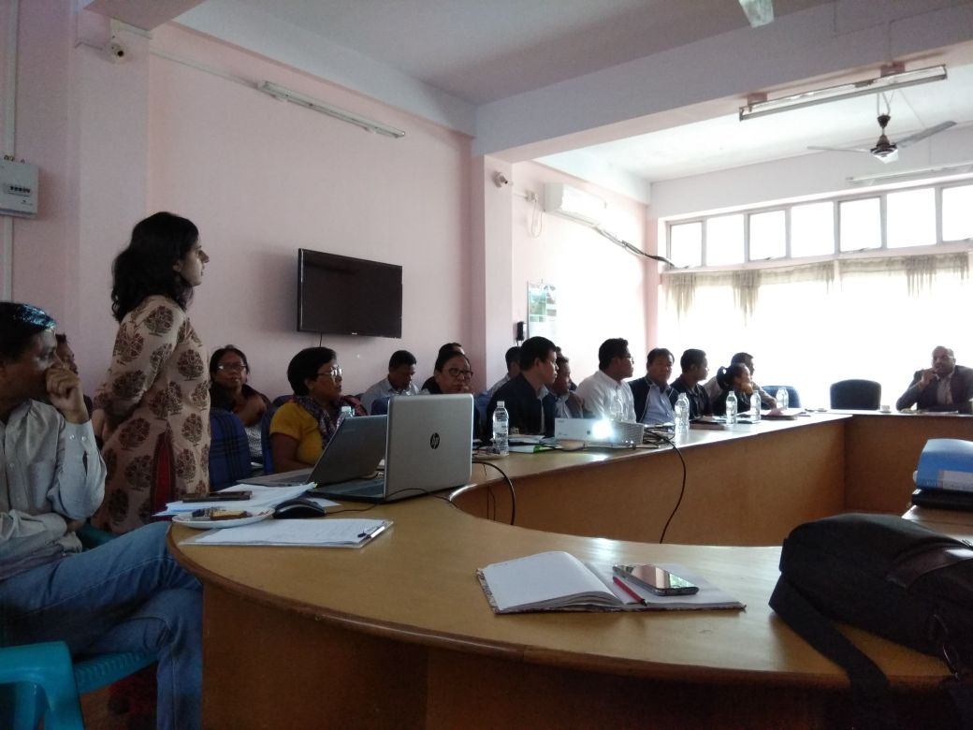

**2. Identification of information required prior a social audit**

Access to information is a fundamental pre-requisite to facilitating the participation of community in planning and evaluation of programmes. Therefore, identifying and having access to the information required for social audits from 11 Departments became the priority. Before the social audits began, it was imperative to know the following for each programme:

* Key entitlements that the programme seeks to deliver
* Steps involved in the delivery of the service and job chart of officers involved in each step
* List of records maintained and where they are found
* Governance structure of the programme- at the village, block, district and State level
* Mechanism of flow of funds from the State to the village, the events that trigger the fund release and the documents that substantiate release of funds and the purpose for which it was spent
* Committees constituted under the programme, its composition and records of its functioning

Building this body of information for each scheme was something that had not been attempted before. It was acknowledged that all this information was known to the Government officers in the helm of implementation. However, this information was not in the public domain in a format and mode that lends itself to simple comprehension.

A workshop was organized from 10th-12th October 2017 to develop templates in which Departments should share the above information related to the implementation of their respective programmes. Representatives from NGOs, campaigns and networks having substantial experience with the implementation of these individual programmes were requested to participate in the workshop as “External Resource Persons”. Each External Resource Person worked with one Department over the course of the three days to arrive at final templates for each scheme. The participation from the side of Government Departments for these workshops included a State level Programme Officer, Accounts Officer, District level implementing officer and Block level implementing officer to ensure that all aspects of programme implementation were covered in preparing the final templates. The workshop served as a collaborative exercise where both CSO representatives and Government officials could together arrive at the nodes of information that required to be in the public domain, based on their area of expertise.

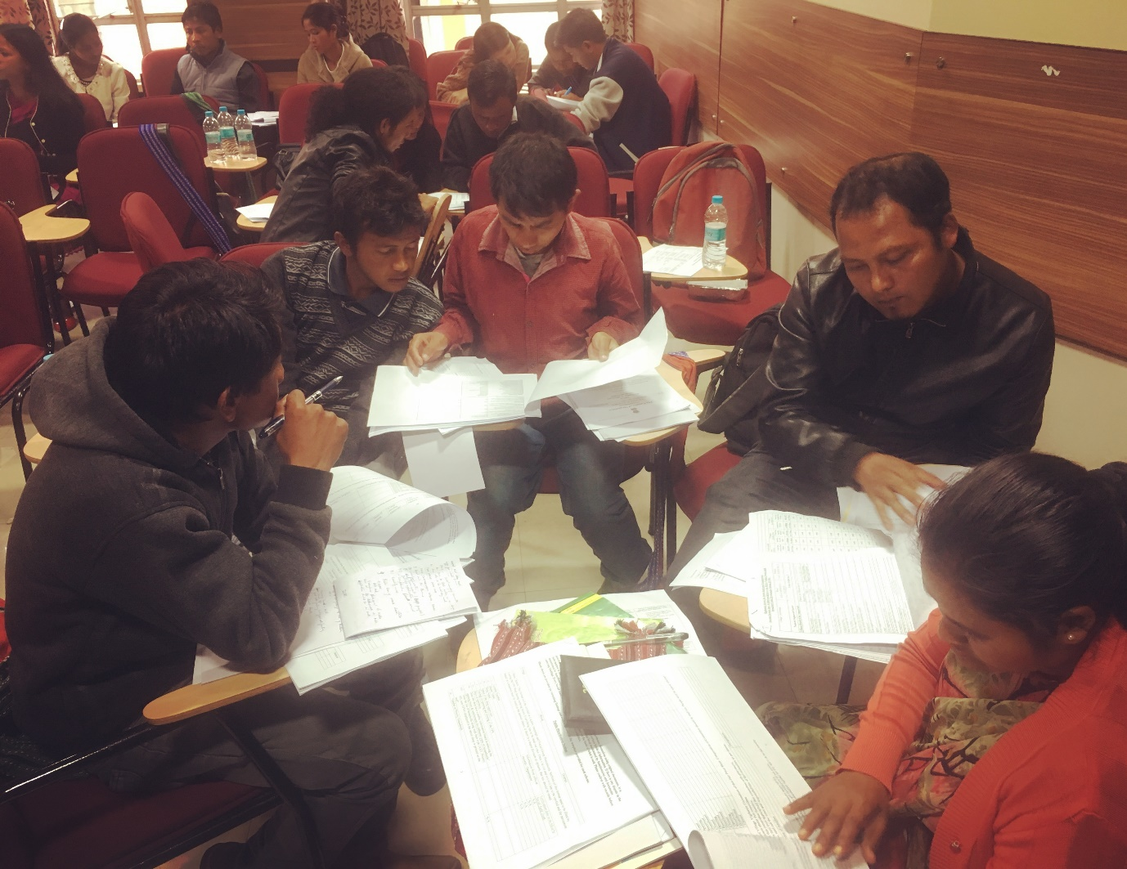

The formats prepared through the workshop were finalized in agreement with Government, and were presented as the format in which each Department has to populate information relevant to the scheme being audited, and submit to the Social Audit teams prior to the audit.

**3. Selection of villages for launch of social audits**

18 villages were identified for the launch of social audits in the State. It was made sure that the villages equally represented the three regions of the State- Khasi Hills, Garo Hills and Jaintia Hills so that at the conclusion of the pilots we could have a comprehensive understanding of the texture of social audits in different regions of the State. The villages were selected on a random basis from a sample that met the following two conditions:

* Having a population of more than 250 households
* Having all schemes to be audited, actually implemented in the village

The villages selected were:

|  |  |  |
| --- | --- | --- |
| Name of District | Name of Block | Name of Village |
| West Khasi District | Mairang Block | 1. Kynrud Village  2. Mawlyngtriang Village  3. Mawnai Village |
| East Khasi District | Khatarshnong Laitkroh Block | 4. 12 Mer Village  5. LewShillong Village  6. Mawkma Village |
| West Jaintia Hills | Amlarem Block | 7. Bakur Village  8. Darrang Village  9. Jarain Village |
| Ri Bhoi District | Umling Block | 10. Diwon Village  11. Khanapara Village  12. Mawsmai Jorabad Village |
| East Garo Hills | Songsak Block | 13. Dobu Bazar Village  14. Anchengbok Village  15. Koki Nengsat Village |
| North Garo Hills | Kharkutta Block | 16. Chotcholiya Village  17. Kharkutla Village  18. Songittal, Megom Akong Village |

**4. Interaction of the Chief Minister with CSOs**

A meeting was organized between the Chief Minister and representatives of CSOs and campaigns working on issues related to transparency and accountability. The meeting included a brief presentation by the Government on the intended plan for rolling out of pilot social audits and the specific areas in which Government sought the support of the community of activists in making the audit credible. It was then followed by an open discussion which included raising of clarifications and concerns related to the method and objective of the pilot social audits, followed by a response to the same from the Chief Minister.

The interaction between the Chief Minister and the local CSOs was important as it acknowledged the role of the multiple stakeholders that need to engage with each other i.e. citizens, traditional institutions, CSOs, the independent Social Audit Unit and Government to make social audits a truly democratic and participatory process.

**5. Accessing required information from Departments**

Once the formats in which information was required to be assimilated, and the list of villages in which social audits would be launched, was finalized- the Departments were requested to provide the required information within a period of 15 days.

A team within MSSAT was tasked with following up with Departments on a daily basis and clarify all queries at the earliest, so that the information could be made available within the time frame requested. Therefore, a pro-active approach was undertaken in order to work with Departments and pull the relevant information out.

**6. Test run of document assimilation**

IN the endeavour of working with Departments to collate the required information, the MSSAT team camped in a village for 2 days to understand for itself how this information would have to be organized from the Department in order to submit it in the formats requested. Once the MSSAT team was successful in organizing all the information requested for as per the format for 1 village within 48 hours, it could negotiate the replication of the same with the State level Departments.

**7. Verification of information submitted**

Once the information was assimilated and produced by the Departments, MSSAT verified whether all the formats were indeed filled up with all the information requested for. Through this process, MSSAT and Line Departments had a continual dialogue to clarify each other’s requirements.

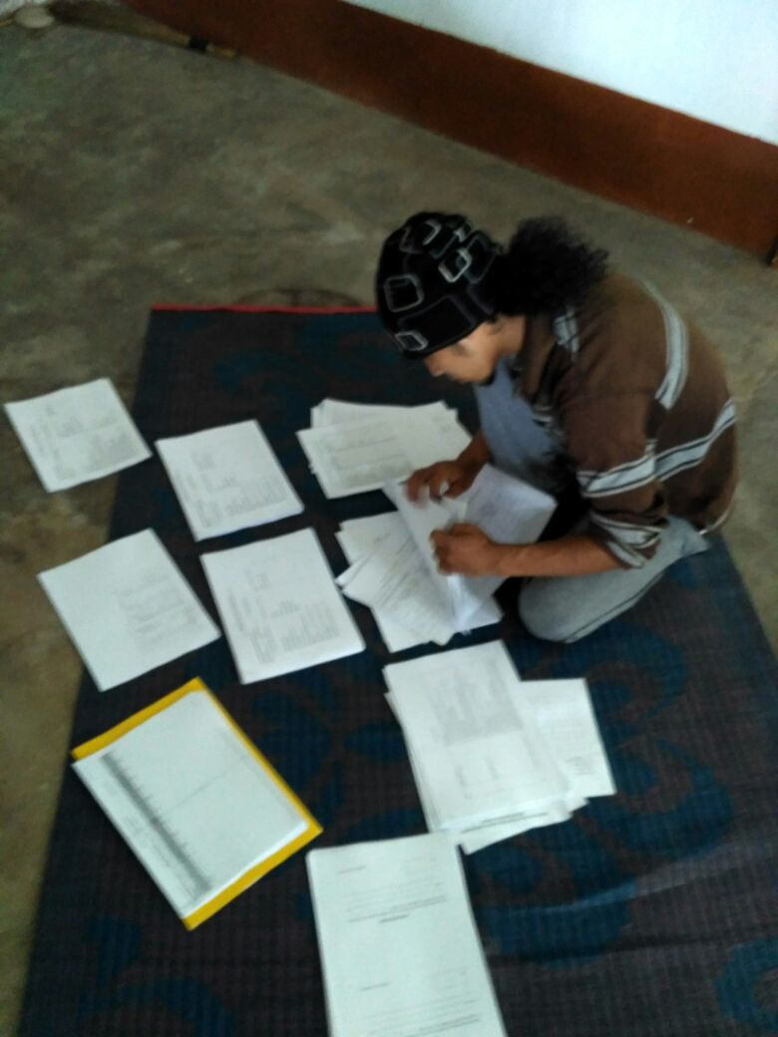

That the formats were indeed populated with the required information was certified by MSSAT and only then were the social audits allowed to begin on the field.

**8. Identification of Social Audit Facilitators**

It was decided that there would be one social audit support team allocated to each village. The Support Team would comprise of the following:

* 1 External Resource Person: Reputed External Resource Persons having experience and knowledge in social audit exercises on the ground were invited to participate in the pilot social audits underway. The intention behind this was so that they could lend support to the exercise. In addition, it was intended that they benefit from this experience and incorporate lessons that emanated from here to their respective states.
* 1 State/District Resource Person, MSSAT
* 3-4 Representatives of NGO’s of the State that have undertaken social audits in the past: It was intended that the social audit team consist of local CSO representatives, to facilitate a wider participation and engagement with CSOs of the State
* An Extension Officer appointed by the District Administration to support the team: Since it was the first time that social audits would be rolled out in this fashion, it was decided to have a Government Officer (not from the village being audited and not involved in the implementation of any of the programmes being audited)
* Members of the Social Audit Committee (SAC) that the General Body of the Village Employment Council is supposed to nominate
* Representatives of the Seng Kinthei (Village Women’s Group) and Seng Samla (Village Youth Group) to ensure that local organized communities participate in the social audit of the village

Members of the social audit facilitators were identified based on request for volunteers and official communication seeking participation.

**9. Training of Social Audit Facilitators**

Once the pool of facilitators were identified, two simultaneous trainings were organized. Teams that would facilitate social audits in Garo Hills were trained in Resebelpura, Garo Hills District and the teams facilitating social audits in Khasi and Jaintia Hills were trained in Shillong, East Khasi Hills District.

A day long training was imparted by MSSAT to the facilitators. A special request was also made to the Block Development Officers of the Blocks in which the pilot social audit would take place to attend the training.

The training consisted of the following components:

* Break up of the 5 day schedule of the social audit
* Steps to be followed in the social audit process, and norms of record keeping and documentation
* Code of Conduct to be followed by the Social Audit Facilitators through the audit period
* Division of responsibilities between administration and social audit facilitators

The facilitators were allocated to their respective teams, and introduced to their MSSAT counterpart. Each team was handed over the documents submitted by multiple Departments for that village, and a kit consisting of all essential items required by the team for the audit such as stationary, important numbers, measuring tape, etc.

**IV. Social Audits**

The core focus of the social audits in Meghalaya were on the following four elements:

* Sharing information about schemes and its manner of utilization with citizens
* Recording irregularities between actual reality and official records
* Recording grievances that people are facing in accessing entitlements
* Identifying list of eligible beneficiaries for individual schemes who are not currently accessing entitlements due to them for any reason

The objective of placing the focus of the social audits on the above 4 elements was to ensure that social audits were understood as a platform for grievance redress and community monitoring. Social Audits for far too long have been incorrectly understood as a post facto analysis of “what went wrong”. Whereas, a social audit is an ongoing process through which the potential beneficiaries and other stakeholders of an activity or project are involved at every stage: from the planning to the implementation, monitoring and evaluation. This process helps in ensuring that the activity or project is designed and implemented in a manner that is most suited to the prevailing (local) conditions, appropriately reflects the priorities and preferences of those affected by it, and most effectively serves public interest. Social audits were therefore deliberately positioned as a platform by which citizens can not only question and hold the administration accountable for what was its mandate, but also actively participate in planning and enabling course correction in implementation.

The following was the social audit process that was followed over the course of 5 days

**1. Meeting with the Village Headman**

The Social Audit Support Team was asked to conduct an “entry meeting” with the Village Headman to explain the purpose of the social audit exercise and the activities that it will include. It was important to begin the process with an interaction with the Headman so that the latter had ample opportunity to clarify doubts if any. It was also symbolically relevant to begin the exercise in the village subsequent to an interaction with the Headman as he is considered as the most respected elder in the village and it was important for him to be seen as extending support to the initiative.

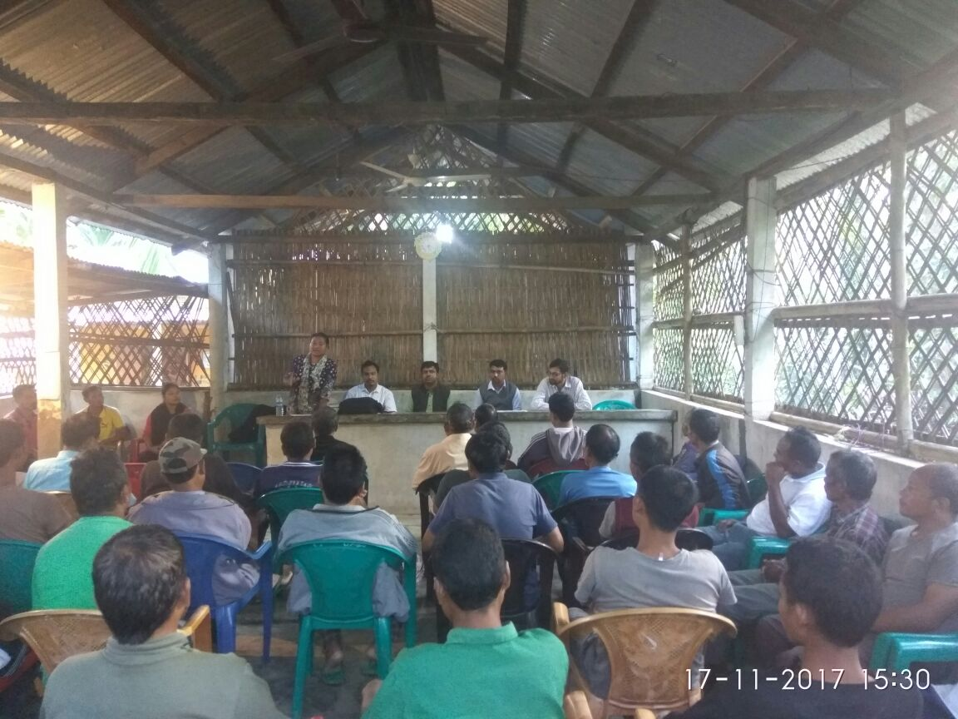

**2. Locality meetings**

Since the Social Audit Support Team had to complete a social audit of more than 10 programmes over a span of 5 days, door to door verification was understood to be unpractical in the given context. Audit teams were advised to map localities that formed the village.

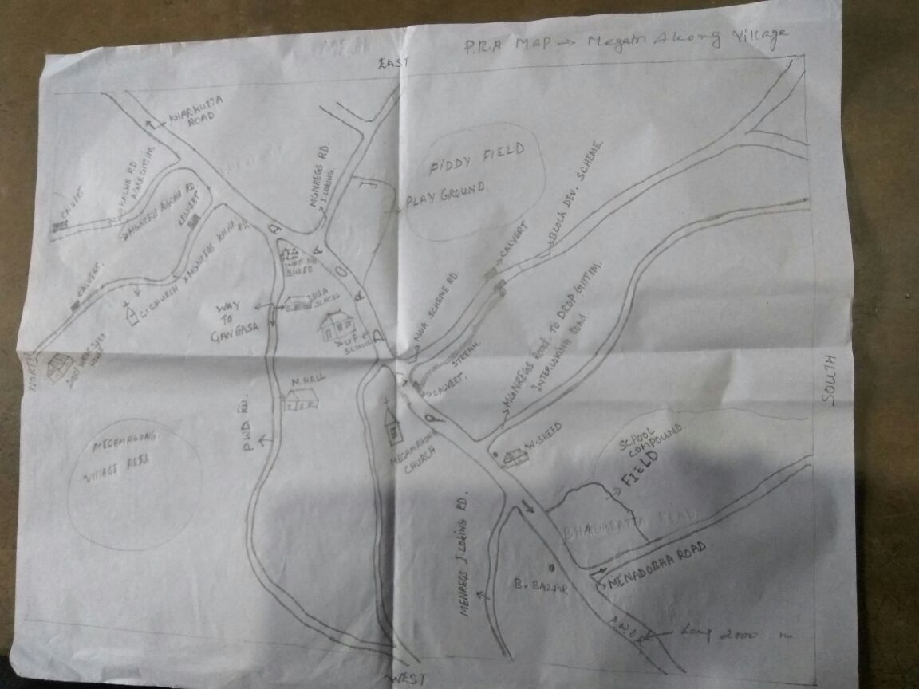

They were then advised to proceed with locality visits one by one and do the following in each locality visit:

* Distribute pamphlets on social audit, its importance and what are the activities that are expected to roll out in the next few days
* Request people to assemble at a common area in the locality. Mics were at the disposal of the Social Audit Team and the team was asked to think of creative ways of mobilizing people to attend a meeting.
* Read out the accounts and records of schemes implemented in the scheme for the locality. Amongst the social audit team pairs were formed for each scheme. The pairs allocated for different schemes should sit separately, so that people wanting to know more information about a particular scheme would go towards the concerned pair.
* Read out beneficiary lists, item wise expenditure and note down findings as per the formats. In case people wanted to apply for schemes, the Social Audit Support Team were asked to help them fill out application forms. In case there were grievances, teams were asked to help fill out grievance forms.
* Pairs within the Social Audit Support Team were asked to visit institutions, works and points of service delivery and fill out the social audit formats.

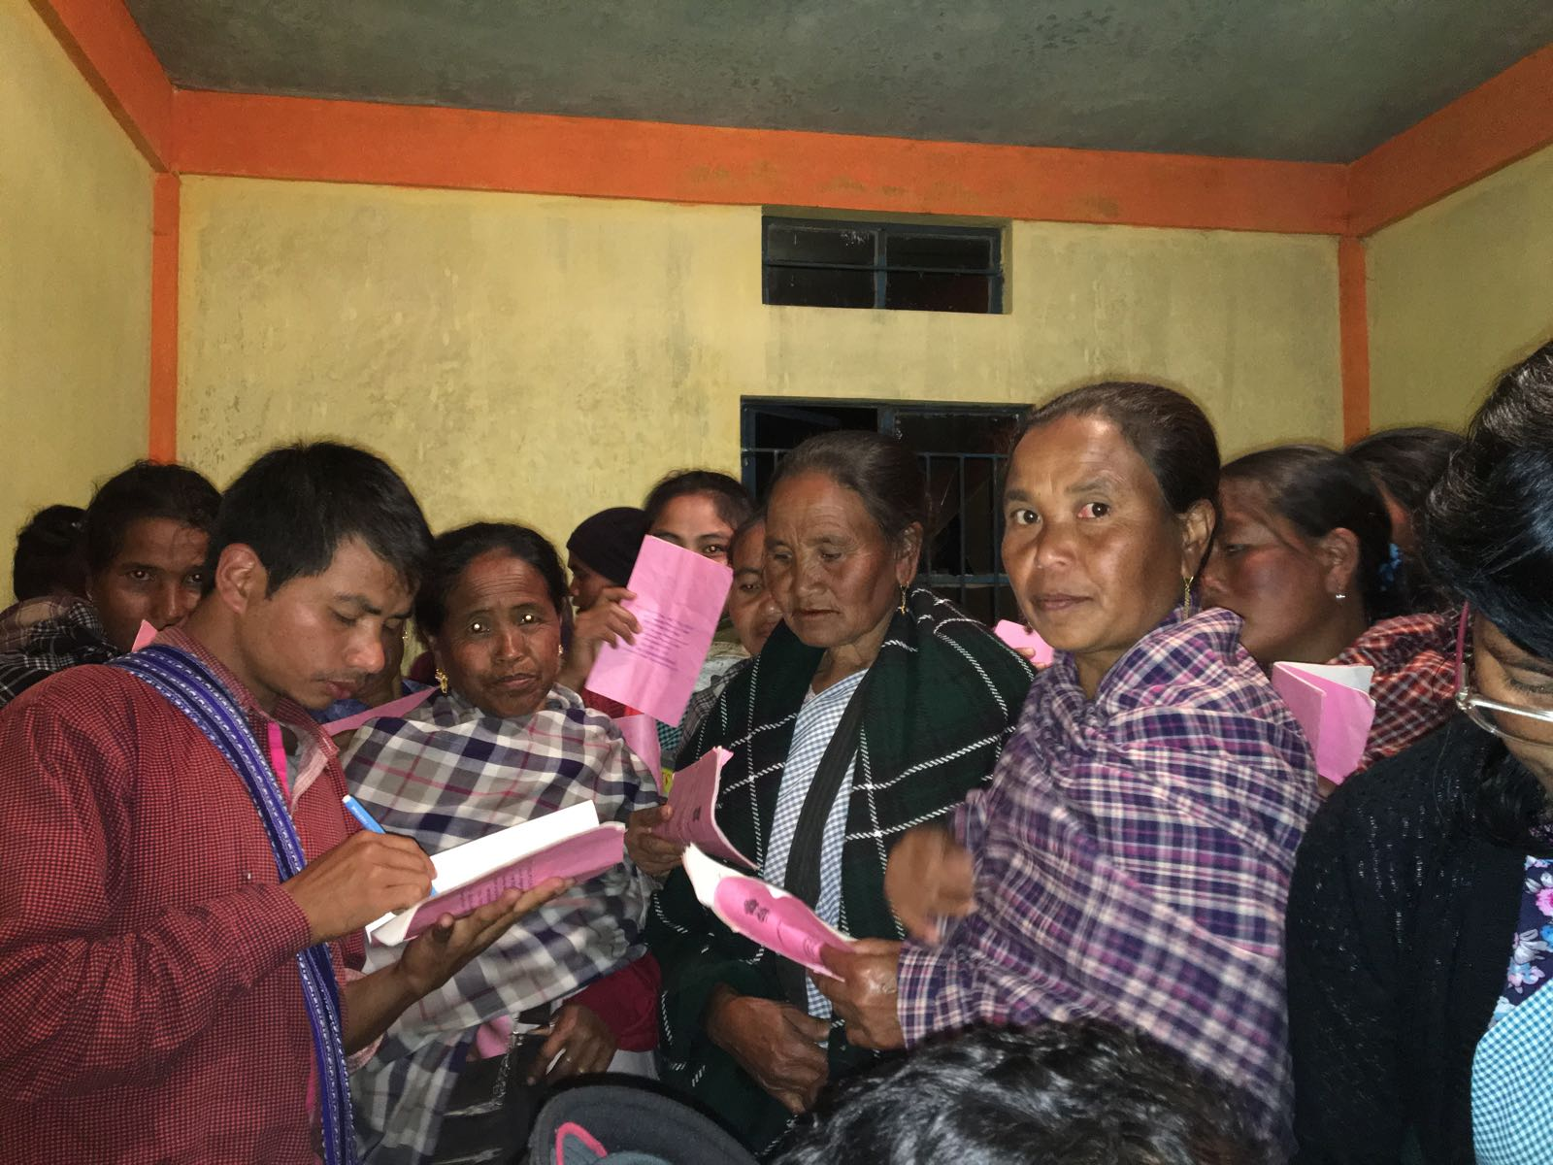

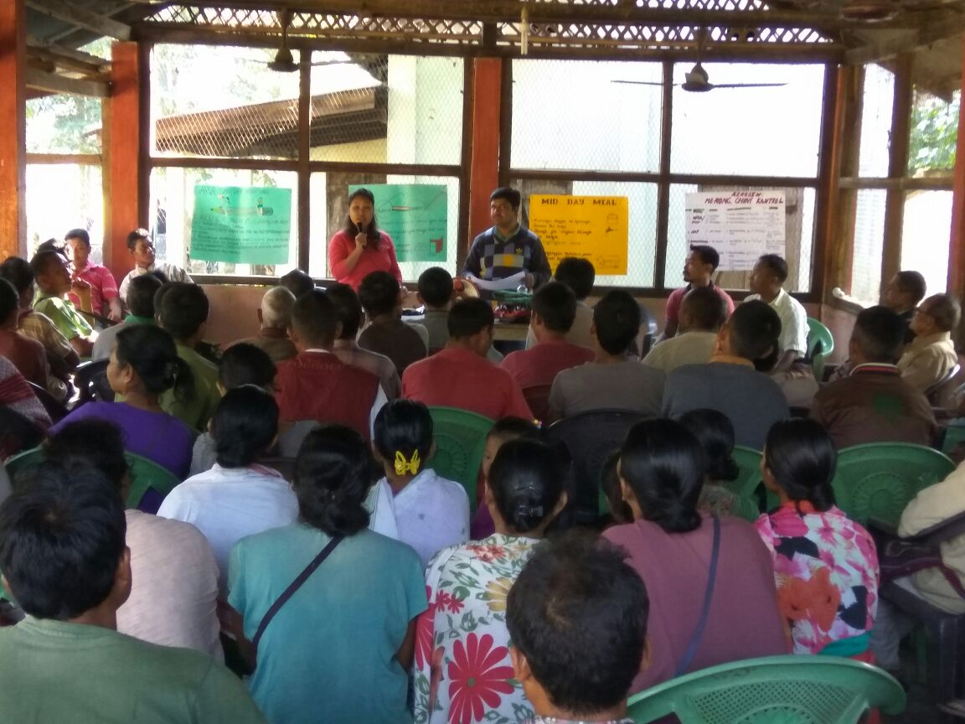

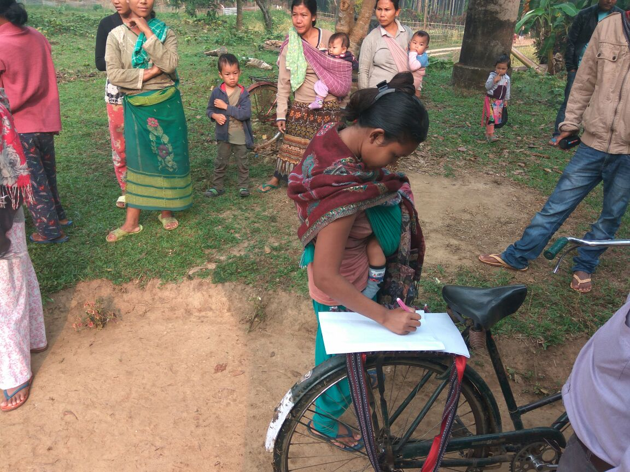

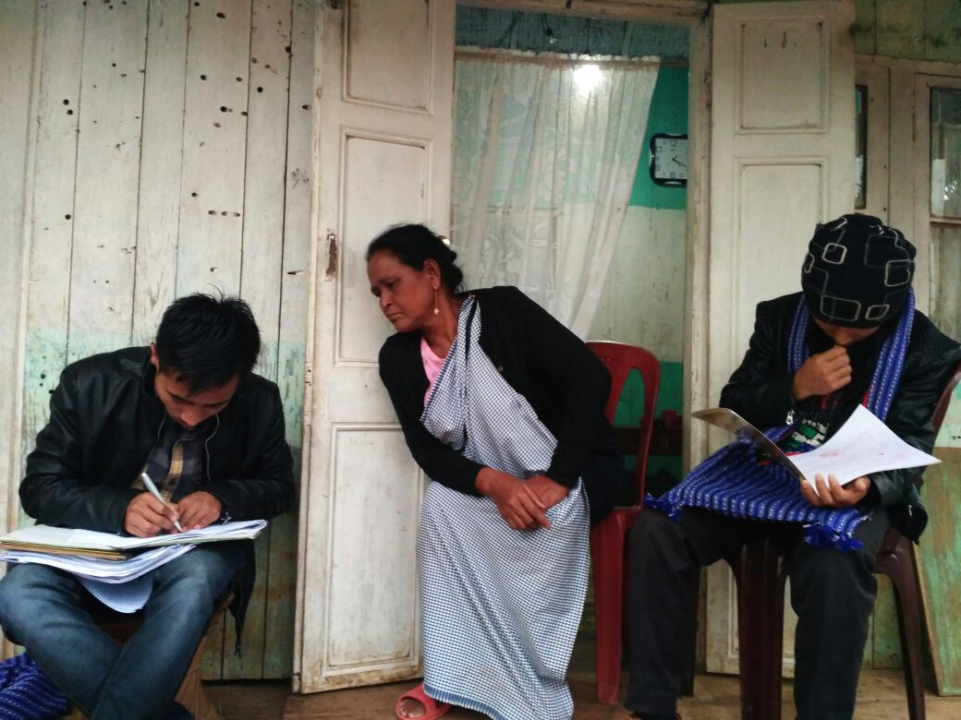

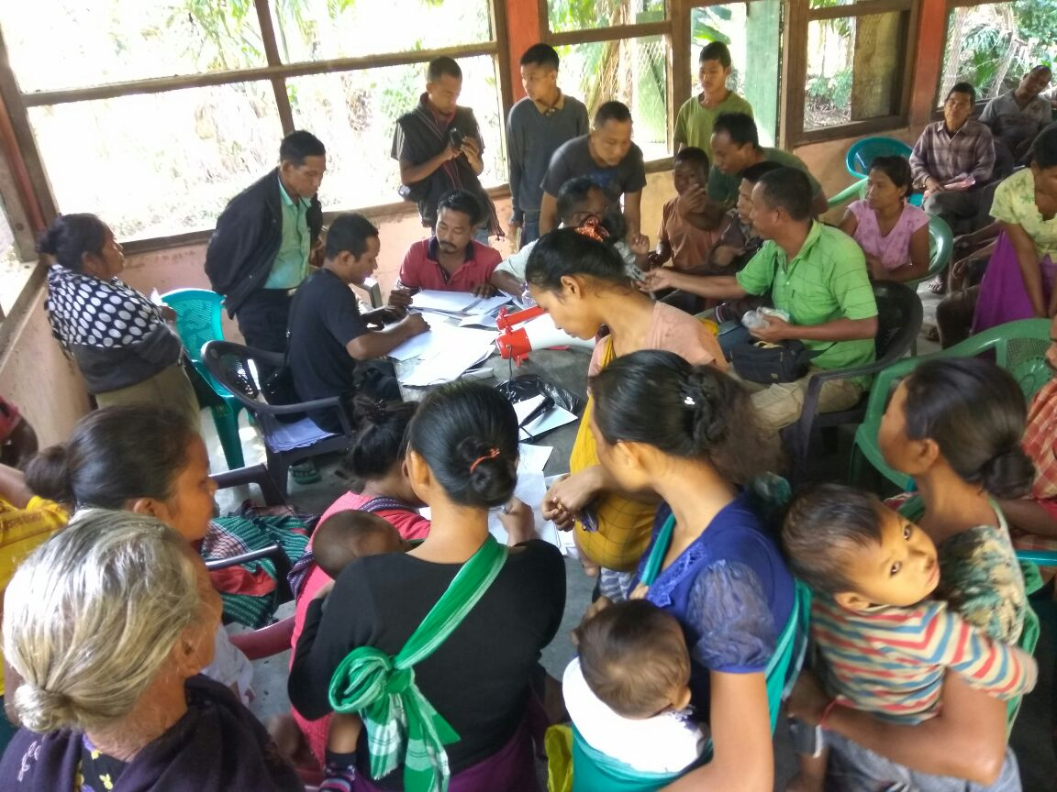

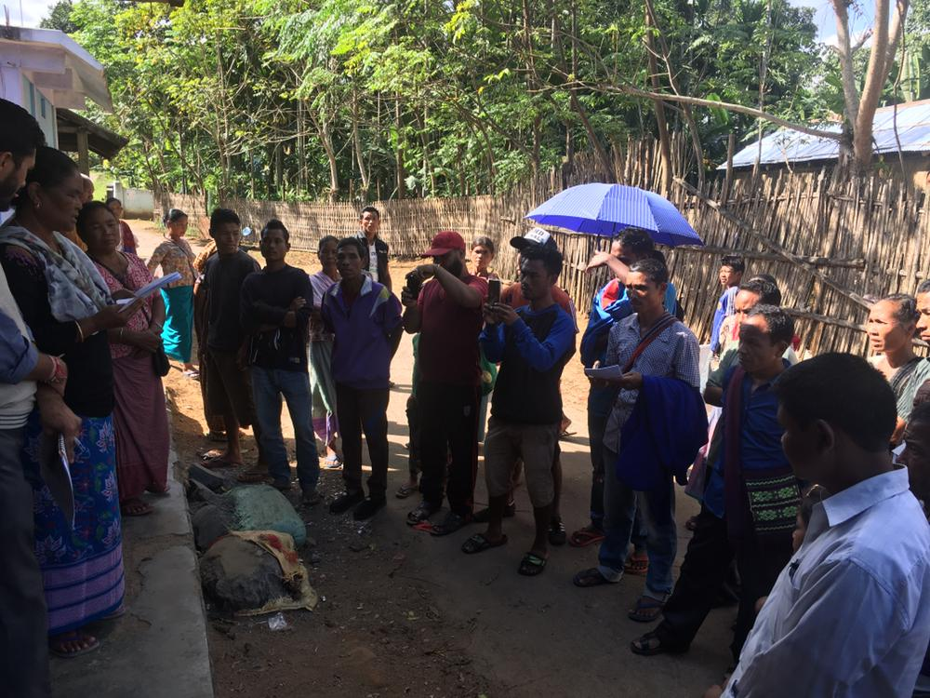

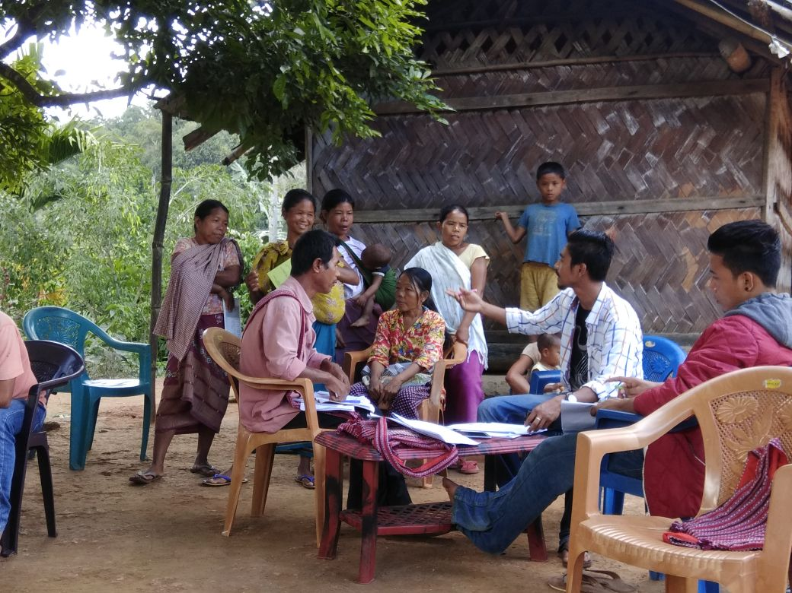

The Social Audit Support Team had a very important and responsible role to play in ensuring that the process of social audit maintained a high standard of integrity and ethics. The team was entrusted with a task of supporting people in accessing their rights and entitlements and bringing into public gaze any shortcomings there might be in implementation. Because this often involves asking uncomfortable questions and bringing out irregularities and even cases of corruption, the team members themselves and their behaviour were going to be under constant focus and attention. They were asked to follow a particularly high standard of ethics and mature behaviour to maintain the credibility of the entire social audit process. For this reason, all social audit support team members had to sign a code of conduct and ethics and follow it sincerely while they are assisting this process.

The code of conduct included:

* Team members will maintain all accounts of expenditure for the social audit and be ready to share this in a transparent manner
* Team members will take care to respect local cultural norms and customs and not speak rudely with anyone. There will be particularly careful not to respond to provocation but report any untoward incident to the group leader.
* There will be no consumption of alcohol or other addictive substances by any team member during the course of the audit. No team member will discriminate on the basis of gender.
* Team members will pay for their own food and accommodation will be organized by MSSAT following a simple lifestyle
* Hospitality will be avoided from any member of any implementing agency
* Team members will understand that they must live in the village and a social audit process continues round the clock. Any person in distress who comes and asks for assistance will be heard and supported as per the protocol of the social audit
* Team members will be courteous with each other and any difference of opinion will be discussed and sorted out in a daily team meeting.
* It will be the duty of every team member to try and ensure that unheard voices reach the social audit public hearing. People, particularly vulnerable individuals and local groups, can speak out free of fear. Team members is only playing a supportive role. Team members are not the auditors. The people are the auditors. Response and redressal shall come from the Government. Therefore the team should not provide any false assurance. Team members must make sure that whatever they say is backed by evidence and documents. Any questions that people ask must be responded to in the full spirit of transparency
* Team members will record their observations and findings (as per the formats) and will attempt to make sure that the concerned people attend the social audit public meeting, and their issue is discussed.
* Team members will avoid any situation where they might be seen to have a personal interest for or against any matter.
* The independence of the social audit process must be maintained at all times.

**3. Writing of the Draft Social Audit Report**

After wrapping up locality visits and completing the tasks above, the teams were asked to spend a day preparing the draft Social Audit Report which has to minimally contain: i. Findings of the social audit verification exercise scheme wise and locality wise ii. Collation of list of applications and grievance scheme wise and locality wise iii. Preparation of charts that will be used to disclose information on the day of the Public Hearing iv. Preparing an agenda for the Public Hearing consisting of key findings and issues – scheme wise and locality wise

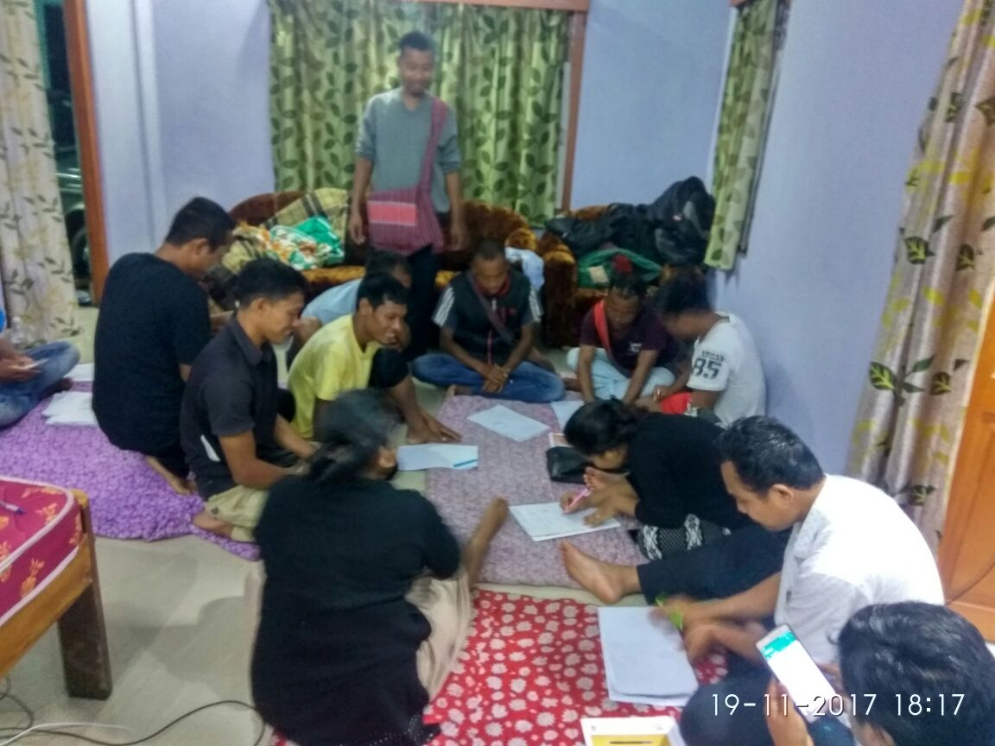

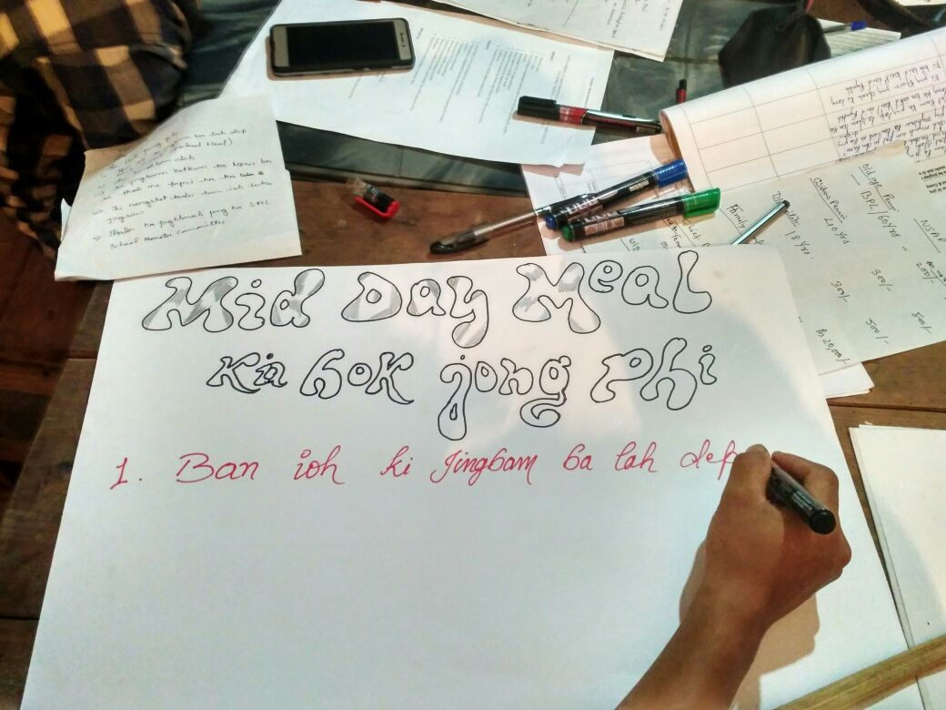

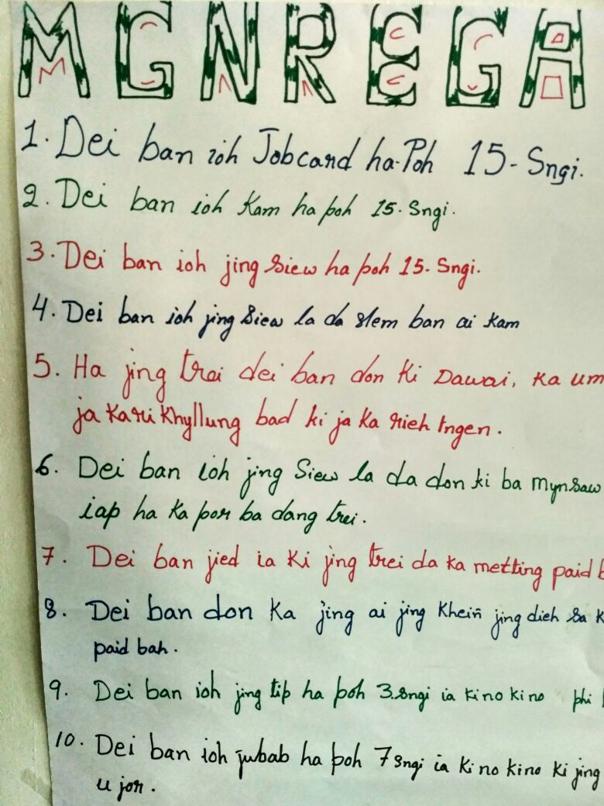

**V. Social Audit Public Hearing**

Right from the beginning, the social audit public hearing was designed to be one that was a social audit cum grievance redress public hearing. The Social Audit Public Hearing was declared to be a general body meeting of the village open to all residents (men and women) and members of the Durbar.

The Public Hearing had a Single Help Desk to accept all applications and grievances brought forward by people. The Desk had to provide two copies of dated acknowledgement receipts for every application and hand it over to the applicant and direct him/her to the appropriate department Desk. At the Department Desk, the applicant was required to retain one copy of the receipt and hand over the second copy of the receipt along with the application form to the Department. The Desk was asked to retain a third copy of each individual receipt for the record.

Every Department was asked to set up a desk/counter at the Public Hearing. The counter was responsible for: i. Processing applications/grievances/petitions received ii. Study each application/grievance/petition as per Departmental norms and make its recommendation. If necessary, it would seek clarification from the applicant and obtain required information/approvals from other Departments if necessary. For all applications seeking individual/collective benefits, if the applicant qualifies, the applicant was either to be awarded sanction on the day of the Public Hearing itself. In the case that sufficient resources were not available to accord sanction to all those who applied, a priority based waiting list was to be created which had to be announced in the Public Hearing. iv. Place all the registers and files pertaining to the schemes implemented by the Department on the desk so that it can be viewed by citizens

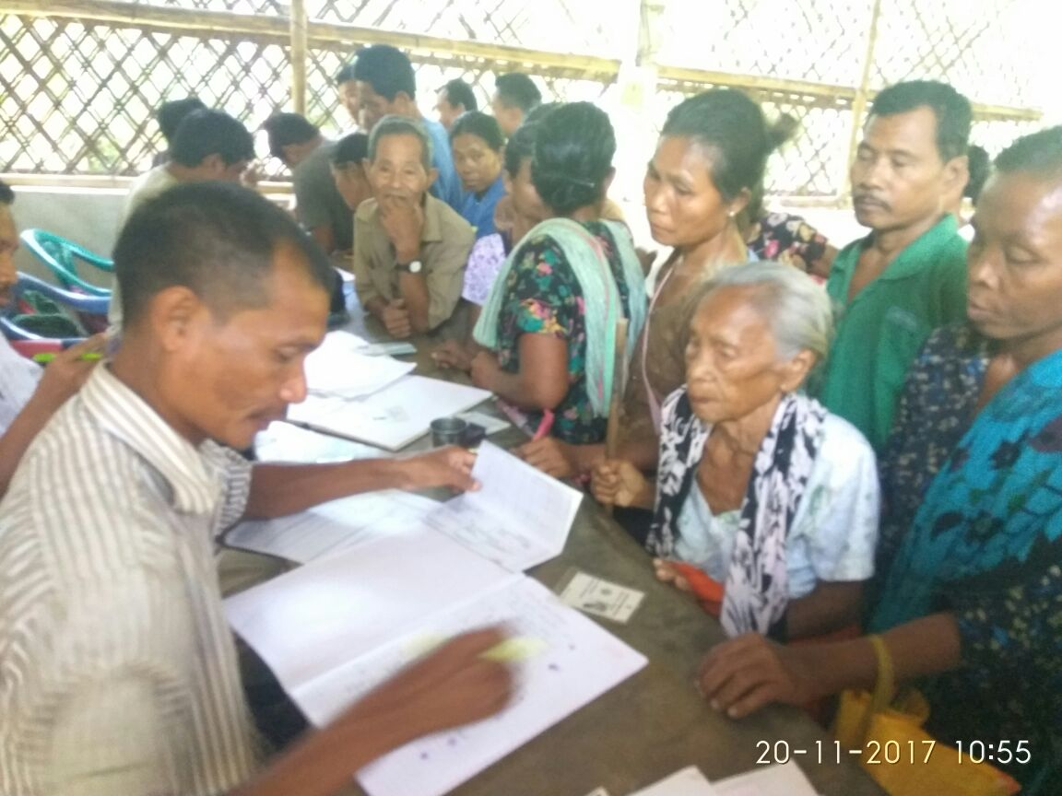

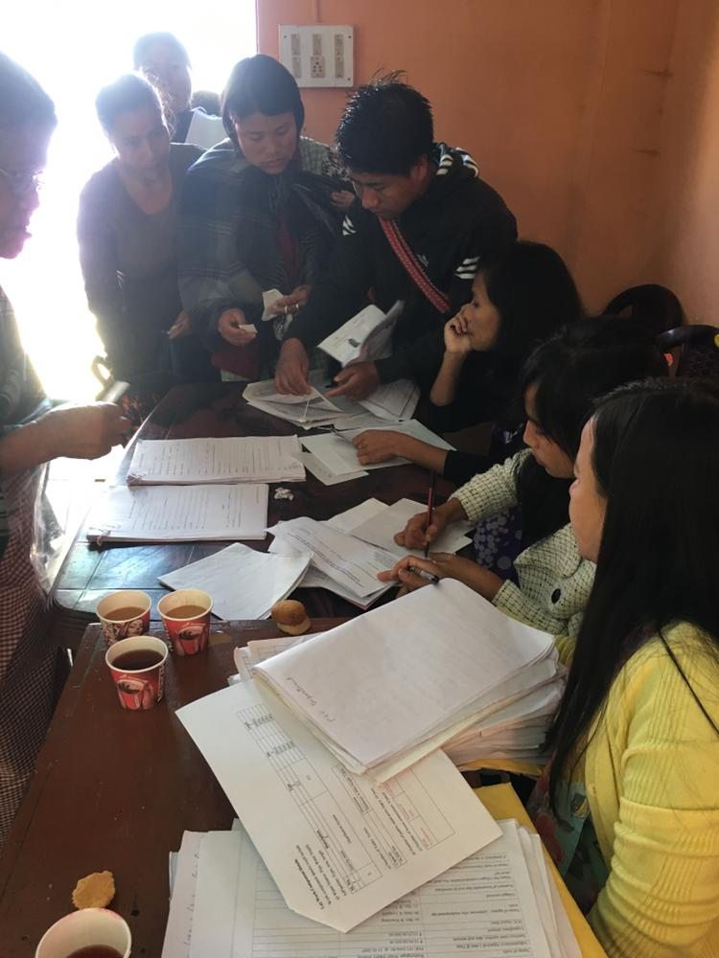

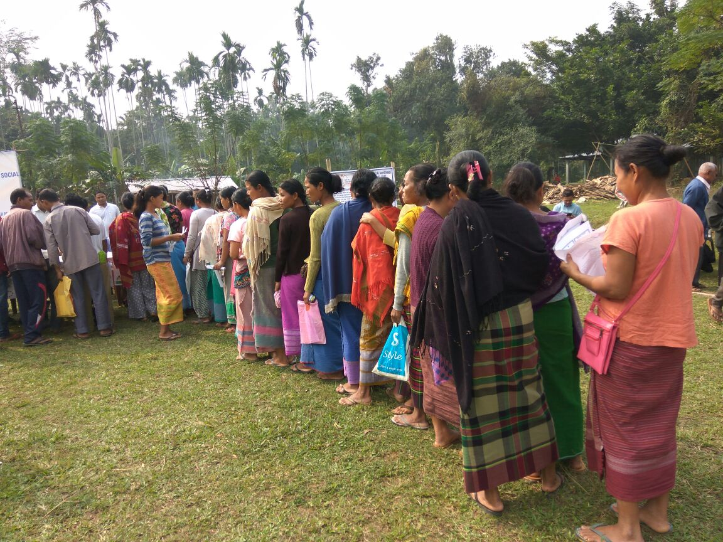

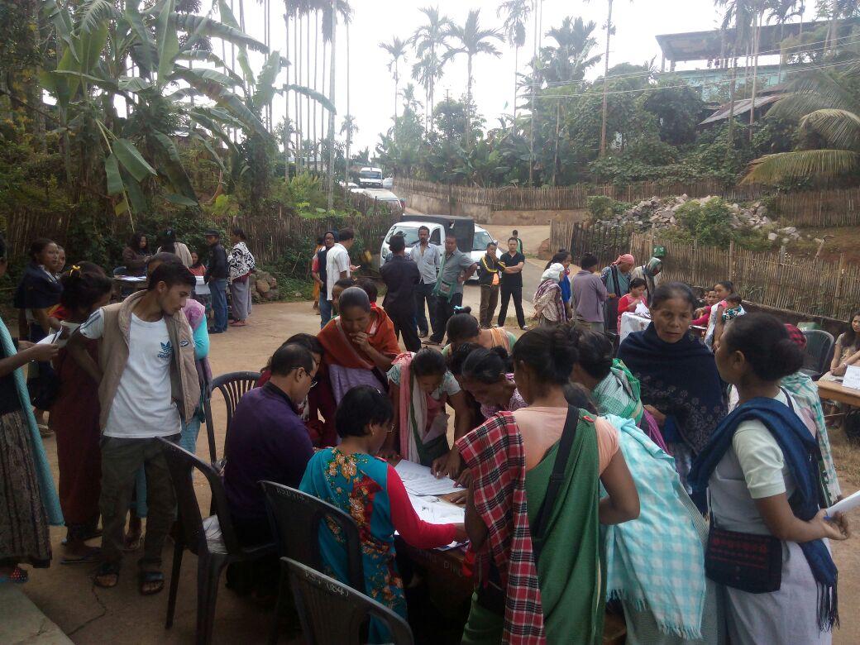

After the citizens had completed their interaction with the Single Help Desk and Departmental Counters, the Public Hearing would commence. The Public Hearing was to be presided by a panel consisting of the following:

* Village Head
* Deputy Commissioner/ nominee
* Block Level Implementation Officers of the various schemes being audited
* NGO/CSO Representative who is not from the Block
* Representative of MSSAT
* Representative of the Autonomous District Council

The Social Audit Team would begin reading out the findings of social audit for individual Departments. Summary of the information pertaining to the scheme and its expenditure was read out. This included summary of the applications filed on the day of the Public Hearing and the response of the Department on the same. Applicant/Complainants were given a chance to comment on the response of the Department in front of the panel. The Panel was asked to take a decision/make recommendation on each finding which would be announced and recorded in the minutes.

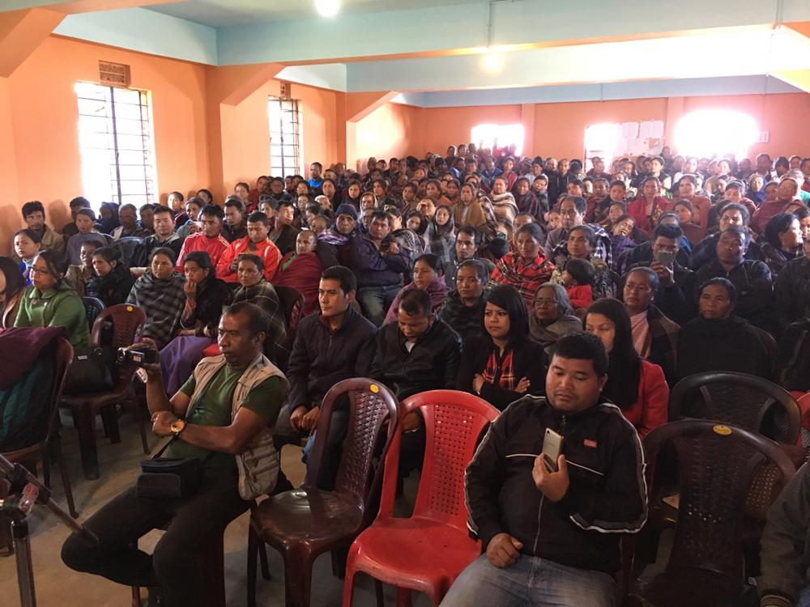

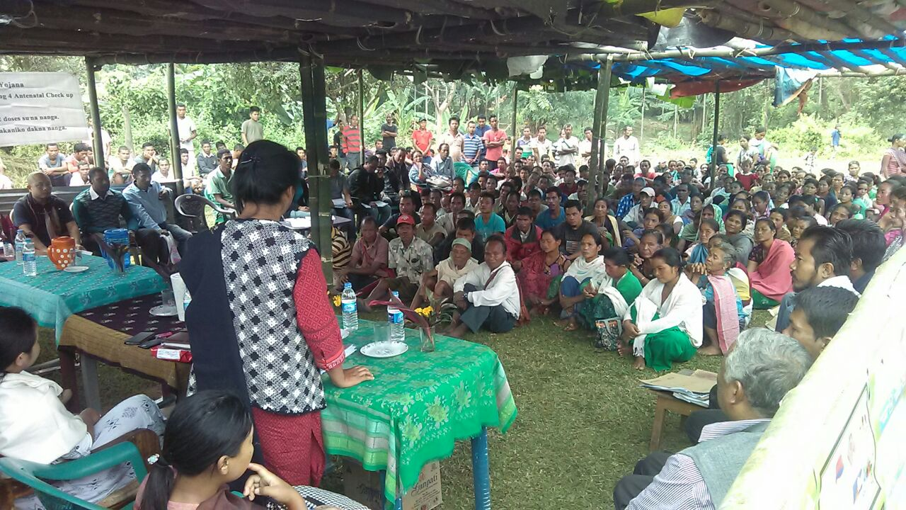

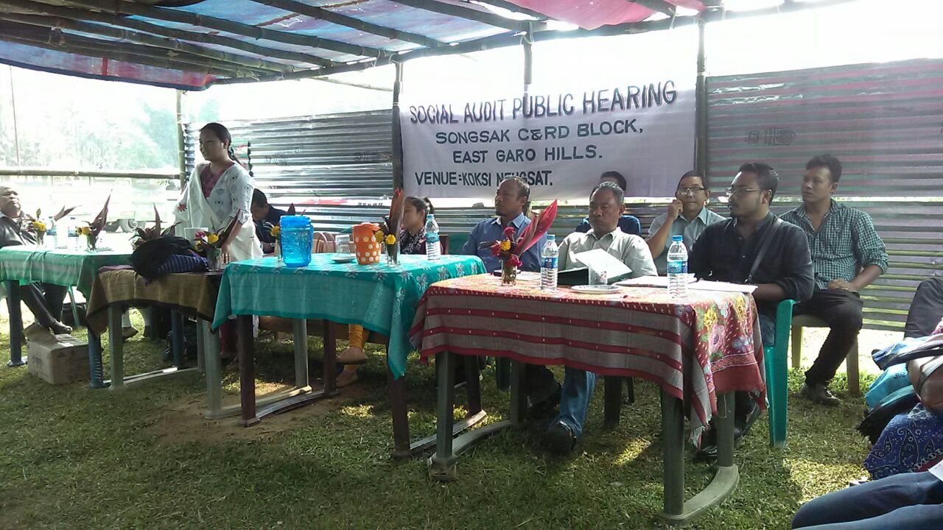

Social Audit Public Hearings were successfully organized in all 18 villages. More than 1000 applications and grievances have been received across 18 villages with a focus on availing benefits under various schemes and reporting violation of entitlements. More than 5000 people participated in the Social Audit Public Hearings that took place on the 22nd and 23rd November to hear social audit findings and give their feedback. 180 local youth got trained in social audits and Village Monitoring Committees of 15 schemes were made to get familiarized with their mandate and roles.

**VI. Social Audit Reports**

Final Social Audit Reports that incorporated the decisions taken on the day of the public hearing were prepared and uploaded in the public domain – http://mssat.nic.in/index.php/mssat_controller/reports_mssat

The Reports were forwarded to the concerned Deputy Commissioners for taking action and filing “Action Taken Reports” within 15 days.

The pilot social audits thereby resulted in the creation of a rich body of content which includes:

* Code of Conduct
* Pamphlet
* Social Audit Workbook
* Formats in which Departments are to share information prior to a Social Audit
* Social Audit Reporting Formats
* Draft Rules
* Draft Manual

**VII. Social Audits – Evidence Based Policy**

The pilot social audits undertaken brought to the surface irregularities in the implementation of programmes. Some of the irregularities required redress and correction at the local level. Whereas, some of the irregularities clearly pointed to systemic issues of policy that need changes at the State level.

Section 3 of the MCP&PSSA Act emphasizes course correction in policy based on evidence generated through the social audit, as one of its core objectives:

*“3. The objectives of the MCP&PSSA are:*

*b) To monitor the effectiveness and efficiency of the implementation of the development programmes and public services in a time bound manner and initiate course correction measures wherever necessary*

*f) Social Audits shall be used for the purposes of finding the facts at the field level in the implementation of the programme and improve upon them*

*g) Seek suggestions from the people on ways and means of improving implementation of development programmes and public programmes*

*h) Provide a platform for airing of public grievances and ensure a time bound redress of the same”*

The following were the required policy changes that were identified through the pilot social audits in 18 villages, but needed be introduced in the schemes for proceeding towards systematic course correction across the State

|  |  |  |
| --- | --- | --- |
| Name of scheme | Policy finding | Policy suggestion |
| **Mid- Day Meal** | 1. There is a discrepancy between the number of children consuming the mid day meal in schools and the number of children costed for at the time of budgets being sanctioned. Since the former is more than the latter, the budget sanctioned for mid day meal in a school is not adequate to feed all children coming. | 1. Department should carry out a survey of all children consuming the mid day meal in schools and identify the real number of children such that budgets are allocated to each school as per real estimates. |
|  | 2. Food is not provided on a daily basis under Mid Day Meal. Upon verification, it was found that was because the sanctioned cooking cost per unit is inadequate for providing a hot cooked meal on a daily basis and therefore meals are provided some days a week/month. | 2. The State Government may consider increasing the state share towards payment for the cooking cost per unit such that the cooking cost per unit is adequate for providing a hot cooked meal on a daily basis. |
|  | 3. The cook responsible for preparing mid day meals does not report to work on a daily basis owing to the low monthly honorarium (Rs 1000 per month). As a result children do not get a hot cooked meal on a daily basis. | 3. The State Government may consider increasing the state share towards payment of the monthly honorarium to the mid day meal cook. |
|  | 4. Absence of disclosure of information at the point of service delivery | 4. Department must ensure that every school mandatorily discloses the following information:  a. Name of Mid Day Meal Cook  b. List of children enrolled in Mid Day Meal Scheme  c. Daily menu of Mid Day Meal |
| **Sarva Shiksha Abhiyan** | 5. Schools do not have a boundary wall with proper fencing | 5. Each VEC should take up construction of school boundary wall in the MGNREGA shelf of projects and complete it within a stipulated time frame |
|  | 6. It is not possible for parents to buy two sets of uniform within the financial entitlement of Rs 400 per year | 6. The State Government may consider increasing the state share towards payment for uniform |
|  | 7. Absence of disclosure of information at the point of service delivery | 7. Department should ensure that the following information is disclosed at the school:  a. Composition of the School Management Committee  b. Budget sanctioned to the SMC  c. Expenditure of the funds allocated to the SMC including listing of the items on which expenditure was undertaken  d. List of teachers teaching in the school |
| **Public Distribution System** | 8. Beneficiaries are underprovided and overpriced for their legal entitlement of rice, wheat, sugar and kerosene compared to the legal entitlement due to them under the National Food Security Act. The alibi presented universally by all the FPS Dealers was that this was owing to the Dealer compensating for the cost of transportation that he/she had to personally incur. | 8. State Government must ensure that foodgrains, sugar and kerosene are distributed to the dealer and should incur the costs of transportation. Cost of lifting of foodgrains, sugar and kerosene should not be incurred by the FPS Dealer, as it will inevitably be passed on to the beneficiary. |
|  | 9. Rate and quantity at which rice, kerosene, sugar and wheat is distributed varies from village to village due to lack of awareness amongst people about norms. | 9. Every FPS should have a board listing down the quantum and rate at which foodgrains, sugar and kerosene are to distributed for each kind of beneficiary (PHH, non NFSA, Annapurna, AAY) |
|  | 10. Distribution of kerosene is not entered on the Ration Cards nor in the distribution register of the FPS. The kerosene dealer is different from the FPS Dealer and is not subject to the same norms of record keeping as the FPS Dealer is required to | 10. Department must ensure that Ration cards of all beneficiaries are updated and the complete record of offtake is entered on it on by 30th December 2017. |
|  | 11. Non NFSA Beneficiaries do not have Ration Cards in their custody. | 11. Departments must ensure that all non NFSA beneficiaries are distributed their Ration Cards by 30th December 2017. |
|  | 12. Discrepancies are reported between stock distributed as per FCI and stock received as per FPS Dealer. | 12. Department must ensure the provision of a weighing machine in every FPS and distribution of foodgrains as per weight and entitlement. |
|  | 13. Absence of disclosure of information at the point of service delivery | 13. Department should ensure that the following information is disclosed at the Fair Price Shop:  a. Name of Dealer and opening and closing time of the FPS  b. List of beneficiaries including the category they belong to (PHH, non NFSA, AAY and Annapurna) and quantum of foodgrain, sugar and kerosene distributed to them in the last quarter  c. Rate and quantity of foodgrains that each category of beneficiary is entitled to  d. Stock of rice, wheat, sugar and kerosene for the quarter  e. Composition of the FPS Vigilance and Monitoring Committee |
| **Swach Bharat Mission** | 14. There is confusion about the mode of payment to beneficiaries for construction of IHHLs. Sometimes cash is provided to beneficiaries, whereas sometimes the Village Water Sanitation Committee provides material for construction in kind to beneficiaries. The arrangement was seen to vary from District to District. | 14. Department must issue clear instructions about norms of payment for IHHL beneficiaries |
| **Pradhan Mantri Awaas Yojana** | 15. There are many citizens who deserve/need a pakka house, but whose names are not included in the SECC Priority Waiting List. | 15. Department must prepare a list of all those HHs who have made applications for a house under PMAY and forward the same to the Central Government for inclusion. |
| **National Social Assistance Programme and Chief Ministers Pension Scheme** | 16. The beneficiaries of NSAP and CM Pension Scheme are different. Discretion is used by field functionaries in deciding who will be the beneficiaries under these two schemes, as the quantum of benefit varies. | 16. The State Government should consider using funds for the CM Pension Scheme as a means of:  a. Topping up the monthly pension to NSAP beneficiaries  b. Increasing the base of NSAP beneficiaries such that all those eligible are given the benefit |
|  | 17. The pension amount is debited once a year | 17. Department needs to ensure that pension disbursements take place on a monthly basis. State Government may consider constituting a revolving fund to make monthly disbursements, in case the sanction from GoI is delayed. This will ensure that the payments take place on a monthly basis to beneficiaries and State Government’s Revolving Fund gets reimbursed as and when funds are released from GoI |
| **Integrated Child Development Scheme** | 18. AWCs do not have dedicated buildings of their own | 18. Department must complete a survey of all Anganwadi Centres in the State and identify those AWCs which do not have a dedicated building of its own. Department must ensure that every AWC in the State has been sanction a dedicated building of its own by 30th December 2017. |
|  | 19. There is no provision of a hot cooked meal on a daily basis | 19. Departments need to ensure that a hot cooked meal is provided to all children on a daily basis.  2. The menu for the hot cooked meal should be displayed at the AWC so that parents and children know the meals that will be provided |
|  | 20. Provision of THR is not on a daily basis and not as per the quantities mandated. This is particularly because THR distribution is not as per measurement. | 20. Department must ensure that every AWC is equipped with adequate measurement tools such that THR is distributed on a daily basis as per norms |
|  | 21. Absence of disclosure of information at the point of service delivery | 21. Department should ensure that the following information is disclosed at the AWC:  a. Name of Anganwadi Worker  b. Opening and closing time of the Anganwadi  c. Quantum of Take Home Ration that the AWC is supposed to distribute to mothers and children  d. Menu of the cooked meals that the AWC is supposed to provide  e. List of children who attend the AWC  f. List of pregnant women who visit the AWC  g. Stock of the foodgrains that the AWC has |
| **Public Health Education Department** | 22. Many public institutions were found to not have dedicated water supply or toilets | 22. PHED must survey all AWCs, Schools, Sub Centres in the State and identify those units which do not have dedicated water supply. PHED must ensure that projects for providing dedicated water supply to those AWCs, Sub Centres and Schools which do not have them are sanctioned on a suo-moto basis, without waiting for proposals to emerge from the Administration. |
| **National Health Mission** | 23. The Village Health Nutrition Day does not take place once a week as per a predetermined schedule | 23. Department must ensure that the dates for the VHND are publicised properly and people are aware of the date in advance  2. Department must ensure that the VHND takes place as per a calendar |
| **Janani Surakshi Yojana** | 24. There were multiple instances of women eligible for JSY, but not availing the benefit. This was largely due to them not being aware of their entitlement as the ASHA had not informed them | 24. Department should issue orders which enable hospital authorities to hand over the financial entitlement to the beneficiary at the time of delivery. |
| **Mahatma Gandhi National Rural Employment Guarantee Act** | 25. No proper procedures for tendering, procurement of material, recording purchase and utilization of material was found on the ground. This included:  a. No date on bills  b. No names of suppliers on vouchers  c. Payments made in cash to local supplier  d. All bills maintained in ‘kacha’ form  e. Firms CST/GST Number not indicated on bills and vouchers  f. Bills are not bearing the signature of beneficiaries (in the case of individual works)  g. Attendance of skilled workers is not recorded on the Muster Rolls | 25. To put an immediate end to irregularities in material procurement the Department must issue orders on record maintenance of material expenditure. The orders must include the need for preparing ‘Citizen Estimates’ and/or ‘Janta Estimates’ of works that illustrate material estimated and material used along with its rates in terminology that is citizen friendly. |
| **All Schemes** |  | 26. The various village level monitoring/Vigilance Committees constituted to ensure that beneficiaries over see and monitor the implementation of the programmes- must not have any individual who is responsible for the implementation of the programme in it. |
|  |  | 27. A training needs to be organized for members of village level monitoring and vigilance committees on the roles and responsibilities of its members. |
|  |  | 28. Departments must clearly list the following for each scheme:  a. Quantum and rate of entitlements  b. Eligibility requirements that the citizen has to meet to qualify as a beneficiary  c. Documents that need to be submitted by the citizen to apply for benefits  d. Timelines within which the Department is mandated to respond  e. Tangible norms of service that a citizen is entitled to  f. Details of officers to whom grievances can be registered with  The above needs to be produced in the local language (Khasi/Garo) and distributed in all villages. |

**VIII. National Convention on Social Audit**

The Government of Meghalaya organized a launch of the Law and showcase the success of the pilots on 15th- 16th December 2017 in Shillong, Meghalaya through a National Convention on Social Audit. Citizens and Facilitators who participated in the pilot shared their experience with people from other parts of the state in order to spread the message of the law and get their suggestions. Prominent intellectuals, activists, academics, members of the CAG, Central Information Commissioner and journalists were invited to join in revisiting of the pilots, and understand its significance. The objective of the Convention was to draw on their suggestions and experience to see how this process can be strengthened.

Based on the evidence thrown up by the pilot social audits, on the occasion of the National Convention the Chief Minister announced a series of policy reforms. These included:

|  |  |  |  |
| --- | --- | --- | --- |
| S.No | Scheme | Policy announcement | Additional financial implication |
| 1. | Mid Day Meal Scheme | State Government will take up with Govt of India to additional Rs 2 to the per child towards cooking cost to ensure daily provision of hot cooked meal to all children studying in schools across the State | Rs 21.2 crore if prices as per FY 2015-16 are used, and Rs 42.4 crore if prices as per FY 2017-18 are used). |
| 2. | Public Distribution System | Government will issue instructions to the DCs to make sure that transportaion cost provided to the FP Shop dealers. The Govt. shall take steps to bear the cost of transportation of food grains to the doorstep of the Fair Price Shop Dealer to ensure distribution of entitlements as per rates under the National Food Security Act |  |
| 3. | Ration Cards for all non-NFSA beneficiaries | Ration Cards of all Non NFSA Beneficiaries will be distributed to them by 30th December 2017 | None |
| 4. | Mahatma Gandhi National Rural Employment Guarantee Act | Every school will have a boundary wall built for it under MGNREGA | None. As NREGA funds are demand based |
| 5. | Integrated Child Development Scheme (ICDS) | All those Anganwadi Centres that do not have dedicated buildings for it will be identified, and work will be undertaken to construct the same under MGNREGA | None. As NREGA funds are demand based |
| 6. | Public Health Engineering Department | The Department will identify all Schools, Anganwadi Centres and Sub Centres in the State that do not have a dedicated water supply and ensure that water supply connections are built |  |
| 7. | Pensions | The Government will bring parity between financial benefit available to beneficiaries under NSAP and CM Pension Scheme. A total of 52,000 NSAP beneficiaries will be benefitted under this initiative. | Rs 15.6 crore  (250*12*52000) |
| 8. | Universal Coverage of pensions | The Government will identify all those citizens eligible for entitlements under NSAP and sanction their applications on a pro-active basis |  |
| 9. | Monthly disbursal of pensions | The Government will ensure disbursal of pensions to beneficiaries on a monthly basis by building a Revolving Fund in the State |  |
| 10. | Mandatory Disclosure | 1. The Government will ensure that information related to list of entitlements, list of beneficiaries, item wise record of expenditure, budget sanctioned, composition of village committees are disclosed at every point of service delivery 2. Encourage use of local terminology for quantifying goods and service being delivered | None. |
| 11. | Janani Suraksha Yojana (JSY) | The Government will ensure issuing of JSY benefit through cheque to all the eleigible mothers immediadely after the delivery at the respective institution. |  |
| 12. | Draft Rules under Meghalaya Community Participation and Public Services Social Audit Act | Draft Rules under Meghalaya Community Participation and Public Services Social Audit Act will be notified by 30th January 2018. A High Powered Committee representing all stakeholders will be constituted for ensuring that this be done. | None. |
| 13. | Transparency and Accountability | Every Department will apportion 0.25% of its Annual Budget to financing social audit, grievance redress and mandatory disclosures | None |

It is important to note that only Point 7 and 12 were indeed initiated and cleared for implementation (as of 16th February 2018) as far as administrative and budgetary sanctions are concerned.

The Convention also marked the release of Draft Rules to guide the implementation of MCP&PSSA. The Draft Rules were framed on the basis of practical lessons that were learnt through the pilots. The Draft Rules laid down detailed protocols for implementing essential elements of the Law such as roles and responsibilities of the State Social Audit Council, PI&ED and MSSAT; functions of implementation authorities at the State, District and Block level; mandate of village level social audit committees; protocol for social audit; time bound grievance redress; role of CSOs; building of a real time transaction- based web portal and modalities of community participation.

The Draft Rules are currently in the process of being vetted by the Department of Law, subsequent to which they would be notified by the State Government to govern the implementation of the Act for the future.

**VIII. Emerging lessons for Social Audit**

The concept of “Social Audit” is one that is growing far and wide in terms of its scope. This includes the O/o C&AG defining Auditing Standards for Social Audit and thus being the first ever such exercise of a Supreme Audit Institution detailing standards of disclosure of information and role of citizens in auditing public expenditure; the Supreme Court widening the scope of social audit to include within its purview monitoring of the implementation of the Juvenile Justice Act; introduction of the mandate of social audit within the Persons with Disabilities Act and programmes such as National Social Assistance Programme, Pradhan Mantri Awaas Yojana, Swach Bharat Mission and Pradhan Mantri Gram Sadak Yojana indicates that there is an urgent need to come up with a working protocol for facilitating social audits across a range of interventions. The experience in Meghalaya demonstrated one such working protocol.

Along with demonstrating a practical mechanism for conducting social audits across multiple schemes, the experience also lent insight into some basic principles that can be helpful in efforts underway elsewhere for strengthening and expanding the scope of social audit. These include:

* The need to work out ways for demystifying information and its dissemination is critical in the roll out of social audits. Identification of the nodes of information that require disclosure prior to an audit is essential, and need to be worked out in consultation with both Government and CSOs. The latter has the knowledge of what information people need and in what form, and the former has knowledge about where that information is stored and how it can be extracted.
* The idea of identifying ‘Nodal Officers’ in every Department and involving them in planning each stage of the roll out was one that proved strategically helpful. Officials did not feel this was imposed on them all of a sudden, and felt like they were a part of the initiative. Hence, the tendencies of not being able to meet deadlines and resist the quantum of work needed to be completed prior an audit, were substantially minimalized as they knew for themselves its importance.
* There is a need to assert the framework of making social audit a platform for redress, in addition to being a forum for recording irregularities. Social Audits need to be seen as a forum for planning, accessing entitlements, enabling course correction mid implementation, as much as it is understood to be a forum of recording irregularities based on evidence leading to punitive action. Though social audits have always been imagined as a comprehensive public collective platform relevant for all stages of governance, the pilots in Meghalaya lent us an opportunity to demonstrate the same in terms of a concrete protocol
* There is a need to keep the audit of access to entitlements at the centre of the social audit process.
* The pilot social audits in Meghalaya taught us a way to work with village leaders and make them understand social audits as a tool that could work to their advantage. By actively seeking their involvement in the exercise, they were oriented into using the platform of the public hearing as a means of explaining their own strengths and limitations in the governance structure. Social Audits were not positioned as a confrontation to their authority, while ensuring that the minimum principles of independent essential to the audit process were respected at all times.

In a 6th schedule area like Meghalaya, the MCP&PSSA potentially provides democratic tribal communities an opportunity to use their traditional strength of community decision making to shape the nature and implementation of development programmes. However, the benefit of lessons that emerged from the exercise are not limited to the State alone. The MCP&PSS Act and the experience accumulated from the pilots showed us the potential to revamp the paradigm of social audit, to provide institutional platforms and means for enabling direct democracy.

**Draft Rules under Meghalaya Community Participation and Public Services Social Audit Act, 2017**

**1. Rules under Section 1,2 and 3, MCP&PSSA Act: *“Short title, extent and commencement; Definition; Objectives”***

Nil

**2. Rules under Section 4, MCP&PSSA Act: *“Programmes to be audited”***

The following suggests the gradual expansion of the scope of Social Audit

a. Departments will be encouraged to enlist programmes/schemes/interventions implemented by them, in addition to the Schemes already notified under Schedule I of the Act.

b. Departments must propose the inclusion of the above enlisted programmes/schemes/interventions under the ambit of the Act within a timeframe

c. Programme Implementation & Evaluation Department (PI&ED) must set up a mechanism by which citizens can recommend conducting of social audits for government programmes

**3. Rules under Section 5, MCP&PSSA Act: “*Implementation and Monitoring Authorities”***

Nil

**4. Rules under Section 6, MCP&PSSA Act: *“State Social Audit Council”***

The following suggests the norms of functioning of the Council and its mandate

a. Selection of the Chairperson, Social Audit Council as stipulated under Section 6(2)(a) and non- officio members as stipulated under Section 6(2)(d)

A Selection Committee comprising of the following members shall be constituted to select the Chairperson and Non-Officio members of the Social Audit Council:

i. Chief Secretary, Government of Meghalaya

ii. Principal Accountant General, Government of Meghalaya   
iii. Civil Society Organization representative as suggested by the O/o the Chief Secretary   
iv. Member, Lokayukta

b. The selection committee shall select the Chairperson and Non-Officio Members based on a short list of potential candidate furnished by the PI&E Department.

c. The short list of potential candidates furnished by the PI&E Department shall be disclosed in the public domain 15 days prior to it being forwarded to the Selection Committee so as to invite suggestions and comments from the public. The PI&E Department shall forward the short list of potential candidates prepared by it along with the comments received from the public on the same to the Selection Committee for its decision

d. Selection of ex-officio members as stipulated under Section 6(2)(b) and (c) of the Act

The following members of the Social Audit Council will be appointed by the State Government:

i. Principal Secretary of all Departments whose schemes are listed in Schedule I of the Act

ii. Deputy Chairman of the Khasi Autonomous District Council, Jaintia Autonomous District Council and Garo Autonomous District Council

iii. Deputy Commissioner of one District from each of the three regions- Khasi, Garo and Jaintia. The district represented shall rotate every 2 years.

e. Commissioner and Secretary, PI&E Department will serve as the Member Secretary of the Social Audit Council

f. Tenure of Members: The Chairperson and Members shall hold office for a term of five years from the date on which he/she enters office and shall not be eligible for reappointment

g. Minimum representation: It shall be ensured that 33% of the membership in the Council comprises of women

h. Resignation of Members: Any member of the Social Audit Council may, by notice in writing under his/her hand addressed to the Chief Secretary of the State with a copy to the Chairperson, resign his/her office

**5. Rules under Section 7, MCP&PSSA Act: *“Functions and duties of State Council****”*

a. Periodicity of meetings: The Council shall meet once in 3 months

b. The Council shall fulfil the following duties in its mandate:

i. Approval of the Annual Budget of the MSSAT

ii. Approval of the Calendar to be followed by MSSAT in ensuring that social audits are conducted in every village atleast once in 2 years

iii. Review compliance of MSSAT to the approved calendar

iv. Review compliance of social audits conducted by MSSAT with Auditing Standards of Social Audit as developed by the C&AG

v. Monitor uploading of Social Audit Reports in the public domain

vi. Monitor receipt and disclosure of Action Taken Reports by Departments on Social Audit Findings

vii. The Council shall prepare an Annual Report incorporating social audit findings and Departmental action therein which shall be tabled in the Legislative Assembly

viii. Develop and maintain a web portal as mandated under Section 17(4) of the Act, dedicated to host Social Audit Reports, Action Taken Reports and all other information incidental to the same

ix. Conduct quarterly meetings to review action taken by Departments on social audit reports and grievances and applications generated therein   
x. Recommend departmental and inter-departmental frameworks for time bound grievance redress to ensure that grievances identified through social audits are institutionally redressed on a systematic basis and monitor the compliance of Departments on the same

xi. Approve templates to be used by Line Departments for mandatorily disclosing information as mandated under Section 17(3) of the MCP&PSSA Act and monitor the compliance of Departments on the same

c. The Annual Report prepared by the Social Audit Council and laid before the Assembly should contain the following:

i. Number of Social Audits conducted with reference to number of social audits planned for in the Calendar

ii. Status of compliance of social audits conducted with the Auditing Standards of Social Audit   
iii. Department/Scheme wise social audit findings

iv. Department/Scheme wise action taken on social audit findings   
v. Department wise compliance of provision of information to social audit teams fifteen days prior to the Social Audit

vi. Department wise compliance of norms of participation in the Social Audit Public Hearings

vii. Department/Scheme wise those issues of implementation identified through social audits but not adequately addressed by the ATRs

viii. Status of submission of Action Taken Reports by deputy Commissioners and Implementing Agencies

ix. Number and nature of applications and grievances registered through social audits

x. Number of applications and grievances sanctioned and redressed by the Deputy Commissioner/Departments

xi. Number of policy level and inter-departmental issues identified by PI&ED based on Social Audit Reports and their status

xii. Suggestions for policy reform based on social audits

xiii. Number and nature of training conducted   
xiv. RTI Requests received by MSSAT and the Social Audit Council

xv. Complaints received by MSSAT and the Social Audit Council

d. The Social Audit Council shall abide by the provisions of the RTI Act, 2005

e. Financial delegation

i. The Director MSSAT shall be responsible for drawing up a proposed budget of MSSAT for meeting its commitment to conduct social audit in all villages of the State at least once in two years.

ii. The proposed budget shall be forwarded by the Director MSSAT to the Council for its approval.

iii. Each Department enlisted in Schedule I of the Act should allocate 0.5% of its annual budget to MSSAT for funding social audits of its schemes.

iiv. The State Government would transfer funds equivalent to the budget approved by the Council to the MSSAT

**6. Rules under Section 8(a): *Role of the Programme Evaluation and Implementation Department***

The following suggests the mandate of PI&ED in the implementation of the Act

a. The PI&E Department shall constitute an internal Cell headed by an officer not below the rank of Commissioner and Secretary which will be dedicated to the implementation of the provisions of the MCP&PSSA Act. The Cell shall :

i. Be responsible for collating Department wise Social Audit Reports as produced by MSSAT and the Action Taken Reports as produced by the Deputy Commissioners and Implementing Agencies

ii. Identify those areas in the Social Audit Reports for which adequate action is not reflected in the Action Taken Reports produced by the Deputy Commissioners and Implementing Agencies

iii. Hold monthly meeting with MSSAT, Deputy Commissioners and State Nodal Officers to follow up on issues identified under Section b and arrive at a time frame within which the same has to be addressed

iv. Identify interdepartmental areas on which joint action has to be taken and areas of required policy change, that have been unearthed through social audits

v. Make recommendations and arrive at time bound institutionalization for the above through inter-departmental meetings held as and when needed, and once a quarter at a minimum

vi. Forward compilation of Social Audit Reports, Action Taken Reports and areas in the Social Audit Report for which adequate action is not reflected in the Action Taken Reports produced to the Social Audit Council once a month. The same shall be hosted in the public domain

vii. Develop templates and formats for individual Departments to mandatorily disclose information as mandated under Section 17(3) of the Act.

**7. Rules under Section 8(b) of MCP&PSSA Act: *Role of MSSAT***

The following suggests the role of MSSAT in the implementation of the Law

a. The MSSAT shall be responsible for facilitating social audits of schemes enlisted in Schedule I of the Act.

b. The MSSAT shall recruit full time State Resource Persons, District Resource Persons, Block Resource Persons and Village Resource Persons. The recruitment process shall be guided by a Recruitment Policy as approved by the Social Audit Council

c. The MSSAT shall conduct social audits across the State as per a Calendar developed at the beginning of the year. The Calendar prepared by MSSAT and approved by the Social Audit Council shall ensure that social audits are conducted in a village at least once a year. The MSSAT shall prepare a Draft Annual Calendar by 15th February of every year. The Draft Calendar will be disclosed in the public domain for seeking suggestions from the public for a period of 30 days. The Annual Calendar after incorporating agreeable changes shall be approved by 30th March.

d. The MSSAT shall ensure that Social Audit Reports prepared are uploaded on to the web portal within 15 days of the Public Hearing

**8. Rules under Section 9 and 13(3) of MCP&PSSA Act: *Role of District Level Implementation Authorities***   
  
As per the Auditing Standards of Social Audit developed by the O/o C&AG, social audits must be independent of the implementing agency. Therefore, Implementing Agencies whether at the State, District, Block or Village level should not interfere in the conduct of social audits.

In this context, the role of the Deputy Commissioner in the implementation of this Act includes:

a. Provision of Records as enlisted in Annexure 1 to MSSAT fifteen days prior to the Audit

b. Submit Action Taken Reports on findings contained in the Social Audit Reports onto the web portal within 21 days of the Social Audit Public Hearing

c. Facilitate ‘Entry Meeting’ between Social Audit Facilitators and Village Headman, Village Executive Committee and front line functionaries at the beginning of the audit

d. Provide facilities for basic lodging and accommodation to Social Audit Facilitators in the village where the social audit is taking place at the Village Community Centre/School/Anganwadi Centre

e. Ensure participation of implementing agencies at the panel constituted for the Social Audit Public Hearings

f. Ensure that every Department has set up a desk/counter at the Public Hearing. The counter is required to be coordinated by the Block Level Implementation Officer of respective departments. The counter will be responsible for:

i. Processing applications/grievances/petitions received

ii. Study each application/grievance/petition as per Departmental norms and make its recommendation. If necessary, it will seek clarification from the applicant and obtain required information/approvals from other Departments if necessary

iii. Place all the registers and files pertaining to the schemes implemented by the Department on the desk so that it can be viewed by citizens

g. Ensure that the following facilities are provided for on the day of the Social Audit Public Hearing

i. Tent

ii. Water

iii. Seats

iv. Mic

v. Videography

**9. Rules under Section 10, MCP&PSSA Act: *Role of Line Departments***

a. Each Department must create an internal Social Audit Cell which shall be headed by the Nodal Officer as mandated under Section 10(1) of the Act. The Cell shall be responsible for:

i. Ensuring that the concerned officers at the District/Block/Village level submit information that needs to be provided to MSSAT fifteen days prior to the social audit

ii. Collating information that needs to be mandatorily disclosed in the public domain as mandated under Section 17(3) of the Act

iii. Monitor the participation of District and Block Nodal Officers in the Social Audit Public Hearings

iv. Issue detailed guidelines on the nature of action to be taken by Deputy Commissioners for various grievances and applications received through the social audit such that action can be taken and reported in Action Taken Reports within 21 days

v. Every Department is mandated to prepare and disclose the following information for each scheme implemented by it

* List of entitlements
* Eligibility criteria for qualifying as a beneficiary to avail the benefits under the scheme
* Process of application and documents to be submitted
* Departmental process of sanctioning applications along with timelines
* Departmental process of release of funds along with timelines
* Composition of Village Level Committees and their roles
* Grievance Redress procedures along with timelines
* Duties of officers at the Village, Block and District level in the implementation of the scheme

**10. Rules under Section 11 of the MCP&PSSA Act: *Village Level Social Audit Committees***

a. The Social Audit Committee identified by the General Body of the Village/Locality Employment Council as stipulated under Section 11(1) of the Act must include representation from the Seng Samla (or the equivalent Youth Group) and Seng Kynthei (or the equivalent Women’s Group) of the village.

b. The Social Audit Committee identified under Section 11(1) of the Act cannot include any individual who is incharge of implementing schemes in the village.

**11. Rules under Section 15(d)-15(i) of the MCP&PSSA Act : *Social Audit Protocol***

a. The Social Audit Team will spend a minimum of 7 days in the village

b. The following will be the activities that the Social Audit Team will complete on the first day of the social audit

i. Meet the members of the Social Audit Committee as identified by the VEC

ii. Conduct a meeting with the Village Headman and explain the purpose of the social audit. During the interaction between the Social Audit Team and the Village Headman, the venue and time for the Public Hearing shall be decided and shall be communicated to the District Administration

iii. Conduct of a basic training and orientation to the members of the Social Audit Committee

iv. Meet field level functionaries of various schemes and access primary documents according to the format and identify gaps.

v. Allocation of schemes and localities amongst the Social Audit Team

c. The following will be the activities that the Social Audit Team will complete over the next three-four days

i. Interaction with members of Village Level Committees of all the schemes

ii. Verification of records with members of Village Level Committees

iii. Conduct interaction with beneficiaries through door to door visits and/or locality meetings. It will be mandatory for the Social Audit Teams to meet every beneficiary. In their interaction with beneficiaries/citizens, members of the Social Audit Team will:

- give information about their entitlements

- verify records

- Document discrepancies between records and beneficiary testimonies

- Register grievances beneficiaries wish to file

- Facilitate filling up of application forms to be submitted to Line Departments on the day of the Public Hearing.

- Application Forms should be filled and completed with required documentation for all those who express an interest in obtaining benefits under schemes. This is so that sanctions/approvals/waiting lists can be provided by concerned Line Departments in the Public Hearing as per norms of priority decided in the Public Hearing. Similarly for community benefits needed by the village the social audit teams should explain nature of schemes available, and help create proposals where the village seeks to access such a scheme.

iv. Social Audit Teams should help prepare a list of all eligible persons who are not existing beneficiaries.

iv. Conduct visits to physical works undertaken in the village and all points of service delivery. In its visit to the site of work/point of service delivery, the Social Audit Teams will:

- observe quality of the work found on site and discuss utility of work/asset by interacting with users

- Verify work site with records entered into the Measurement Book

- Verify expenditure booked for in bills/vouchers with actual utilization

- Similarly for services, the team will individually and collectively use the prescribed formats to take feedback on prescribed parameters on service delivery

d. The Social Audit Team will conduct at least one evening meeting in the village to spread awareness to the community about social audit and their entitlements

e. Each day will conclude with an internal de-briefing of the Social Audit Team to exchange preliminary findings

f. Social Audit Facilitator Team must take measures to share information in the public domain through the course of the social audit verification

g. The following will be the activities that will be completed by the Social Audit Team on the day before the Social Audit Public Hearing

h. Consolidation of social audit findings and prepare an agenda of key issues and findings raised during the verification process for discussion in the Public Hearing. The agenda must consist of the following components:

- Key findings for each scheme

- List of grievances registered for each scheme

- List of applications filed for each scheme

- Suggested recommendations for strengthening implementation of the schemes in the village

ii. Follow up with the District Administration about the arrangements to be in place for the Public Hearing that shall take place the following day

i. All members of the Social Audit Team will mandatorily stay in the village for the entire duration of the social audit. District Administration is required to make arrangements for stay and food at the village community hall/public school. Care must be taken that the teams will not take hospitality (food, accommodation etc) with anyone involved in the implementation of schemes, in order to maintain independence.

j. Team members will maintain all accounts of expenditure for the social audit and be ready to share this in a transparent manner

k. Team members will take care to respect local cultural norms and customs and not speak rudely with anyone. There will be particularly careful not to respond to provocation but report any untoward incident to the group leader.

l. There will be no consumption of alcohol or other addictive substances by any team member during the course of the audit. No team member will discriminate on the basis of gender.

m. Team members will pay for their own food and accommodation will be organized by MSSAT following a simple lifestyle

n. Hospitality will be avoided from any member of any implementing agency

**12. Rules under Section 18 of the MCP&PSSA Act: *Public Hearing* *Protocol***

a. The social audit exercise will conclude with a Public Hearing. The Social Audit Public Hearing will be a general body meeting open to all residents (men and women) and members of the Durbar.

b. Members of the Social Audit Team will set up a Single Help/Facilitation Desk which will register all applications. It will provide two copies of dated acknowledgement receipts for every application and hand it over to the applicant and direct him/her to the appropriate department Desk. At the Department Desk, the applicant will retain one copy of the receipt and hand over the second copy of the receipt along with the application form to the Department. The Desk will retain a third copy of each individual receipt for the record.

c. Every Department will be required to set up a desk/counter at the Public Hearing. The counter will be coordinated by the Block Level Implementation Officer of respective departments. The counter will be responsible for:

i. Processing applications/grievances/petitions received

ii. Study each application/grievance/petition as per Departmental norms and make its recommendation. If necessary, it will seek clarification from the applicant and obtain required information/approvals from other Departments if necessary

iii. Place all the registers and files pertaining to the schemes implemented by the Department on the desk so that it can be viewed by citizens

d. Department/MSSAT will print and display flexes to disclose information on the day of the hearing

e. The Public Hearing will be presided by a panel consisting of the following:

i. Village Head

ii. Deputy Commissioner/ nominee

iii. Block Level Implementation Officers of the various schemes being audited

iv. NGO/CSO Representative who is not from the Block

v. Representative of MSSAT

vi. Representative of the Autonomous District Council

f. The Social Audit Team will begin reading out the findings of social audit for individual Departments.

g. Summary of the information pertaining to the scheme and its expenditure will be read out. This will include summary of the applications filed on the day of the Public Hearing and the response of the Department on the same. Applicant/Complainants will be given a chance to comment on the response of the Department in front of the panel

h. Findings of the social audit will be read out. This will include case studies, individual testimonies etc. Participants will be given a chance to intervene and comment.

i. The Panel will have to take a decision/make recommendation on each finding which will be announced and recorded in the minutes

j. The minutes of the meeting will be taken by a representative of the MSSAT

k. For all applications seeking individual/collective benefits, if the applicant qualifies, the applicant should either be awarded sanction on the day of the Public Hearing itself. In the case that sufficient resources aren’t available to accord sanction to all those who have applied, a priority based waiting list should be created which should be announced in the Public Hearing.

l. On Social Audit Findings, the Panel will give its recommendations which will also be read out. Individual Departments will submit an Action Taken Report on findings of the social audit to the Deputy Commissioner within 15 days.

m. Deputy Commissioners must ensure that Action Taken Reports are uploaded on the Social Audit Web Portal 21 days within the Social Audit Public Hearing

**13. Rules under Section 13(1) of the MCP&PSSA Act: *Role of Civil Society Organizations***

a. The participation of Civil Society Organizations will be elicited for the following activities undertaken by MSSAT and the PI&E Department

i. Development of training content

ii. Imparting training and capacity building

iii. Extending support to Social Audit Facilitators in the village during a social audit

iv. Participating in the Social Audit Public Hearing and be a member of its Panel

v. Make suggestions to Government in the preparation of the Annual Calendar of Social Audits

vi. Participate in forums of dialogue and consultation institutionalized by the Government to follow up on policy recommendations that emerge from social audits and make further suggestions therein.

**14. Rules under Section 17(4) of the MCP & PSSA Act: *Social Audit Web Portal***

a. The Council shall develop and maintain a Social Audit Web Portal that shall contain the following at the minimum, in addition to the information put forward from time to time :

i. Social Audit Calendar

ii. Social Audit Reports

iii. Action Taken Reports

iv. List of Actions/Recommendations pending

v. Minutes of meetings

b. The Web Portal will be a real time, transaction based management information system that shall disclose social audit findings and action taken on a constant basis

**15. Rules under Section 16 of the MCP&PSSA Act: *Community Participation***

a. No member of the implementing agency should be a part of village level committees constituted under any scheme

b. The same individual cannot be a member of more than 1 village level committee

c. Composition of Village level committees constituted under any scheme are required to be endorsed for continuation in the social audit public hearing

d. Planning, selection of beneficiaries, prioritization of works as done by the committees, should be read out, endorsed and finalized in the social audit public hearing

**Annexe 1**

**Public Distribution System**

|  |  |  |
| --- | --- | --- |
| Village: | Block: | District: |

1) Basic Details:

|  |  |  |
| --- | --- | --- |
|  | Information from official records / Department | *Verification data to be filled by Social Audit Team* |
| 1. License Number |  | N/A |
| 1. Dealer Name |  | N/A |
| 1. Shop Name |  | N/A |
| 1. Name of the shop supervisor |  | N/A |
| 1. Timings of opening and closing of the FPS |  |  |
| 1. Days of operation |  |  |
| 1. Does the shop have a public information board displaying the opening hours & entitlements for different types of households? |  |  |
| 1. Does the list of households along with their type (AAY, Priority HH, non-NFSA) displayed in the ration shop or printed on the wall? |  |  |
| 1. Number of Priority Households |  | N/A |
| 1. Number of Antyodaya Anna Yojana Households |  | N/A |
| 1. Number of Annapurna Households |  | N/A |
| 1. Number of households receiving non-NFSA rice |  | N/A |
| 1. Number of households receiving non-NFSA wheat |  | N/A |
| 1. Number of households receiving sugar |  | N/A |
| 1. Number of households receiving kerosene |  | N/A |
| 1. Is the Village Vigilance Committee functional? |  |  |
| 1. Details of complaints received by higher officials regarding the functioning of this shop and action taken on them |  |  |

2) Stock Table:

|  |  |  |  |  |  |  |  |
| --- | --- | --- | --- | --- | --- | --- | --- |
|  |  | Apr 2017 | May 2017 | June 2017 | July 2017 | Aug 2017 | Sep 2017 |
| AAY Rice | Opening Balance |  |  |  |  |  |  |
| Kgs Received |  |  |  |  |  |  |
| Kgs Distributed |  |  |  |  |  |  |
| Closing Balance |  |  |  |  |  |  |
| PHH Rice | Opening |  |  |  |  |  |  |
| Received |  |  |  |  |  |  |
| Distributed |  |  |  |  |  |  |
| Closed |  |  |  |  |  |  |
| Annapurna Rice | Opening |  |  |  |  |  |  |
| Received |  |  |  |  |  |  |
| Distributed |  |  |  |  |  |  |
| Closed |  |  |  |  |  |  |
| Non-NFSA Rice | Opening |  |  |  |  |  |  |
| Received |  |  |  |  |  |  |
| Distributed |  |  |  |  |  |  |
| Closed |  |  |  |  |  |  |
| Non-NFSA Wheat | Opening |  |  |  |  |  |  |
| Received |  |  |  |  |  |  |
| Distributed |  |  |  |  |  |  |
| Closed |  |  |  |  |  |  |
| Sugar | Opening |  |  |  |  |  |  |
| Received |  |  |  |  |  |  |
| Distributed |  |  |  |  |  |  |
| Closed |  |  |  |  |  |  |
| Kerosene | Opening |  |  |  |  |  |  |
| Received |  |  |  |  |  |  |
| Distributed |  |  |  |  |  |  |
| Closed |  |  |  |  |  |  |

3) List of Village Vigilance Committee of this Fair Price Shop: Composition of Committee should be read out.

|  |  |
| --- | --- |
| Name of member | Designation |
|  |  |
|  |  |
|  |  |

4) Beneficiary Data:

|  |  |  |  |  |  |  |  |  |  |  |  |
| --- | --- | --- | --- | --- | --- | --- | --- | --- | --- | --- | --- |
| Ration card ID number | Name of head of household as per ration card | Year | Type of Household (AAY / PHH / non-NFSA) | Rice as per official records | *Rice as per household member / ration card* | Wheat as per official records | *Wheat as per household member / ration card* | Sugar as per official records | *Sugar as per household member / ration card* | Kerosene as per official records | *Kerosene as per household member / ration card* |
|  |  | 2015-16 |  |  |  |  |  |  |  |  |  |
| 2016-17 |  |  |  |  |  |  |  |  |  |
| 2017-18 |  |  |  |  |  |  |  |  |  |
|  |  | 2015-16 |  |  |  |  |  |  |  |  |  |
| 2016-17 |  |  |  |  |  |  |  |  |  |
| 2017-18 |  |  |  |  |  |  |  |  |  |
|  |  | 2015-16 |  |  |  |  |  |  |  |  |  |
| 2016-17 |  |  |  |  |  |  |  |  |  |
| 2017-18 |  |  |  |  |  |  |  |  |  |

**National Social Assistance Programme (NSAP)**

1) List of pension recipients:

|  |  |  |  |  |  |  |  |  |  |
| --- | --- | --- | --- | --- | --- | --- | --- | --- | --- |
| Name of beneficiary | Beneficiary Age | Pension category | Monthly Pension Amount as per record | *Monthly pension amount as per beneficiary* | Pension start date as per records | *Pension Start Date as per beneficiary* | *Does the person get pension every month without delay? (Yes / No)* | *Does beneficiary pay any amount to post office / bank while withdrawing (Yes / No)* | *Remarks* |
|  |  |  |  |  |  |  |  |  |  |
|  |  |  |  |  |  |  |  |  |  |
|  |  |  |  |  |  |  |  |  |  |

2) SECC List:

|  |  |  |  |  |  |  |
| --- | --- | --- | --- | --- | --- | --- |
| Names of eligible beneficiary as per SECC list/BPL List | Whether eligible beneficiary has applied | Date of Application | Status [Verified and Accepted/Verified and Rejected/Not Verified) | Date of Verification (if Verified) | Reason for Rejection (If Rejected) | *Remarks* |
|  |  |  |  |  |  |  |
|  |  |  |  |  |  |  |
|  |  |  |  |  |  |  |

3) List of applicants (other than in the SECC/BPL list) who have applied for pension :

|  |  |  |  |  |  |
| --- | --- | --- | --- | --- | --- |
| Names of applicant | Date of Application | Status [Verified and Accepted/Verified and Rejected/Not Verified) | Date of Verification (if Verified) | Reason for Rejection (If Rejected) | *Remarks* |
|  |  |  |  |  |  |
|  |  |  |  |  |  |
|  |  |  |  |  |  |
|  |  |  |  |  |  |
|  |  |  |  |  |  |

**Pradhan Mantri Awas Yojana**

|  |  |  |
| --- | --- | --- |
| Village: | Block: | District: |

1) List of beneficiaries for all houses sanctioned

|  |  |  |  |  |  |  |  |  |
| --- | --- | --- | --- | --- | --- | --- | --- | --- |
| Name of beneficiary and year of allotment | *Was beneficiary selected as per DRDA waiting list or SECC List? (Yes / No)* | Status of house (Started / Plinth / Lintel / Completed) | *Status of house as per field verification (Started / Plinth / Lintel / Completed)* | Installment Number | Amount Disbursed & Date | *Amount received and date* | *Whether the beneficiary had to pay any amount for sanction of house or to get instalment?* | *Remarks* |
|  |  |  |  | 1st Installment |  |  |  |  |
| 2nd Installment |  |  |
| 3rd Installment |  |  |
|  |  |  |  | 1st Installment |  |  |  |  |
| 2nd Installment |  |  |
| 3rd Installment |  |  |

2) List of beneficiaries eligible for housing under PMAY norms from the SECC list:

|  |  |  |  |
| --- | --- | --- | --- |
| Name of eligible beneficiary as per SECC | Waiting List number as per DRDA | Has a house been allotted? If yes, sanction year | *Remarks* |
|  |  |  |  |
|  |  |  |  |
|  |  |  |  |
|  |  |  |  |
|  |  |  |  |
|  |  |  |  |

**Sarva Shiksha Abhiyan**

|  |  |  |
| --- | --- | --- |
| Village: | Block: | District: |

Name of School:  
School Management Type: Govt/SSA/Govt. Aided  
DISE Code:

1) A copy of the latest DISE report for the school should be enclosed.

2) Basic Details of the school

|  |  |  |
| --- | --- | --- |
|  | Data as per official record / department | *Data on verification* |
| 1. Total Boys enrolled: |  | Number of boys present: |
| 1. Total Girls enrolled: |  | Number of girls present: |
| 1. Number of drop-out children in the area: |  |  |
| 1. Number of out-of-school children in the area: |  |  |
| 1. Number of sanctioned teachers for this school: |  |  |
| 1. Number of appointed teachers in this school: |  | Number of teachers present: |
| 1. Names of teachers: |  |  |
| 1. Names of teachers who do not come to school regularly: |  |  |
| 1. Is the school easily accessible to students? |  |  |
| 1. Names of Children with special needs |  |  |
| 1. Are the children with special needs provided adequate support in school? |  |  |
| 1. Month when text books were distributed to children |  |  |
| 1. Month when uniforms were distributed to children |  |  |
| 1. Number of class rooms: |  |  |
| 1. Does each classroom have a black board? |  |  |
| 1. Does each classroom have desks and chairs? |  |  |
| 1. Does school have a play ground? |  |  |
| 1. Does play ground have a boundary? |  |  |
| 1. Does play ground have a level playing field? |  |  |
| 1. Does school have a boundary wall? |  |  |
| 1. Are the playground boundary walls and school boundary walls made of pakka material? |  |  |
| 1. Does school have a regular source of clean drinking water? |  |  |
| 1. Number of functional toilets? |  |  |
| 1. Number of functional urinals? |  |  |
| 1. Does the school have separate toilets for boys and girls? |  |  |
| 1. Do all toilets have a roof? |  |  |
| 1. Do all toilets have a functional door? |  |  |
| 1. Do all toilets have a water source? |  |  |
| 1. Are toilets cleaned regularly? |  |  |
| 1. Honorarium for the cook: |  |  |
| 1. Honorarium for the helper: |  |  |
| 1. Is the cooking staff paid regularly? |  |  |
| 1. Date when the School Management Committee was formed / reconstituted |  |  |
| 1. Is the list of SMC members displayed in the school? |  |  |
| 1. Date when the last SMC meeting was held |  |  |
| 1. Was any training provided to SMC members in the last year? |  |  |
| 1. Are the decisions taken in the SMC meeting recorded in the register? |  |  |
| 1. Are actions taken on the decisions taken and is that recorded in the register? |  |  |
| 1. Date of the last Parent Teacher Association meeting |  |  |
| 1. Number of parents who attended the last Parent Teacher Association meeting |  |  |
| 1. Details of complaints received by higher officials and action taken on them from them school |  |  |

3) Composition of school management Committee:

|  |  |
| --- | --- |
| Name of member | Designation |
|  |  |
|  |  |
|  |  |

4) Copy of the Development Plan prepared by the SMC :

5) Allocation and expenditure of SMC:.

|  |  |  |  |  |
| --- | --- | --- | --- | --- |
| Type of fund | Received from where | Date of receipt | Amount received | Amount spent |
|  |  |  |  |  |
|  |  |  |  |  |
|  |  |  |  |  |
|  |  |  |  |  |
|  |  |  |  |  |

6) Allocation and utilization of grants for FY.

|  |  |  |  |  |  |  |
| --- | --- | --- | --- | --- | --- | --- |
| Name of Grant (School Grant, Maintenance Grant, Teacher Grant) | Total amount allocated as per records | Item of expenditure as per records | Amount of expenditure undertaken on the item as per records | Date of Bill as per records | Name of firm which supplied as per records | *Was item found on site and comments* |
|  |  |  |  |  |  |  |
|  |  |  |  |  |  |  |
|  |  |  |  |  |  |  |
|  |  |  |  |  |  |  |
|  |  |  |  |  |  |  |
|  |  |  |  |  |  |  |

7) Construction work in School:

|  |  |  |  |
| --- | --- | --- | --- |
| Work item | Sanctioned amount | Actual expenditure as per records (item wise material procured and rate of each item procured) | *Remarks based on verification on field* |
|  |  |  |  |
|  |  |  |  |
|  |  |  |  |
|  |  |  |  |
|  |  |  |  |
|  |  |  |  |

8) Distribution of entitlements

|  |  |  |  |  |  |  |  |  |
| --- | --- | --- | --- | --- | --- | --- | --- | --- |
| Name of student | Name of Parent | Class | Textbook distributed as per Records | *Textbooks received as per student* | Uniform distributed as per records | *Uniform received as per student* | Scholarship distributed as per records | *Scholarship received as per student* |
|  |  |  |  |  |  |  |  |  |
|  |  |  |  |  |  |  |  |  |
|  |  |  |  |  |  |  |  |  |
|  |  |  |  |  |  |  |  |  |
|  |  |  |  |  |  |  |  |  |

**Mid Day Meal Scheme**

|  |  |  |
| --- | --- | --- |
| Village: | Block: | District: |

Name of School:  
School Management Type: Govt/SSA/Govt. Aided  
DISE Code:

1) Basic Details:

|  |  |  |
| --- | --- | --- |
|  | Data as per official record / supervisor | *Data on verification* |
| Number of cooks: |  |  |
| Number of helpers: |  |  |
| Names of cooks: |  |  |
| Names of helpers: |  |  |
| Honorarium for the cook: |  |  |
| Honorarium for the helper: |  |  |
| Is the cooking staff paid regularly? |  |  |
| Name of teacher supervising the cook: |  |  |
| Is the menu for the MDM displayed in the school: |  |  |
| Is the MDM as per the menu? |  |  |
| Is an egg supplied as part of the MDM once a week? |  |  |
| Is a fruit supplied as part of the MDM once a week? |  |  |
| Is the School Management Committee formed? |  |  |
| Does the MDM monitoring commitee meet every month? |  |  |
| Does the MDM monitoring committee the MDM program? |  |  |
| Are the decisions taken in the MDM monitoring committee meeting recorded in the register? |  |  |
| Are actions taken on the decisions taken and is that recorded in the register? |  |  |
| Details of complaints received by higher officials and action taken on them |  |  |

2) Composition of MDM Monitoring Committee:

|  |  |
| --- | --- |
| Name of member | Designation |
|  |  |
|  |  |
|  |  |

3) Attendance Data:

|  |  |  |  |  |  |  |  |  |  |  |
| --- | --- | --- | --- | --- | --- | --- | --- | --- | --- | --- |
| Month | Number of days in the month | Enrolment as per register | | | Number attended as per register | | | No of children who had MDM as per register | | |
|  |  | Boys | Girls | Total | Boys | Girls | Total | Boys | Girls | Total |
|  |  |  |  |  |  |  |  |  |  |  |
|  |  |  |  |  |  |  |  |  |  |  |
|  |  |  |  |  |  |  |  |  |  |  |

4) Grain and Cash register data:

|  |  |  |  |  |  |  |  |  |  |  |  |  |
| --- | --- | --- | --- | --- | --- | --- | --- | --- | --- | --- | --- | --- |
| Month | Food grain as per register | | | | Cooking cost as per register | | | | Cook-cum-helper as per honorarium as per register | | | |
|  | Opening Balance | Received | Utilized | Balance | Opening Balance | Received | Utilized | Balance | Opening Balance | Received | Utilized | Balance |
|  |  |  |  |  |  |  |  |  |  |  |  |  |
|  |  |  |  |  |  |  |  |  |  |  |  |  |
|  |  |  |  |  |  |  |  |  |  |  |  |  |

5) List of beneficiaries as per MDM register

|  |  |  |  |  |  |  |
| --- | --- | --- | --- | --- | --- | --- |
| Name of student as per MDM Register | Name of parent / guardian | Class | *Whether actual or not - as per beneficiary* | *Food Regularity* | *Food Quality* | *Food Quantity* |
|  |  |  |  |  |  |  |
|  |  |  |  |  |  |  |
|  |  |  |  |  |  |  |
|  |  |  |  |  |  |  |
|  |  |  |  |  |  |  |
|  |  |  |  |  |  |  |
|  |  |  |  |  |  |  |

**6) Access the MDM Register and verify (approximately) the total number of times the child has accessed mid day meal in the last 3 months.**

**Integrated Child Development Scheme (ICDS)**

|  |  |  |
| --- | --- | --- |
| Village: | Block: | District: |

Name of Anganwadi Center:

1) Basic Details of the Anganwadi

|  |  |  |
| --- | --- | --- |
|  | Data as per official record / department | Data on verification |
| Total Boys enrolled: |  | Number of boys present: |
| Total Girls enrolled: |  | Number of girls present: |
| Name of anganwadi worker: |  |  |
| Name of helper: |  |  |
| Name of lady supervisor: |  |  |
| Does the anganwadi have a working weighing machine? |  |  |
| Does the anganwadi have play material for the children? |  |  |
| Does the anganwadi have educational material for the children? |  |  |
| Is the growth monitoring register maintained? |  |  |
| Does anganwadi have a separate kitchen space? |  |  |
| Does anganwadi have access to safe water? |  |  |
| Does anganwadi have a toilet? |  |  |
| Is the toilet child-friendly? |  |  |
| Is the daily anganwadi menu displayed in the anganwadi? |  |  |
| Opening times of the anganwadi: |  |  |
| Opening days of the anganwadi: |  |  |
| Has a community monitoring committee been formed? |  |  |
| Has the community monitoring committee been provided training? |  |  |
| Is the list of community monitoring committee members displayed in the anganwadi? |  |  |
| Are the decisions taken in the community monitoring committee meeting recorded in the register? |  |  |
| Are actions taken on the decisions taken and is that recorded in the register? |  |  |
| Details of complaints received by higher officials and action taken on them |  |  |

**2**) Composition of community monitoring committee:

|  |  |
| --- | --- |
| Name of member | Designation |
|  |  |
|  |  |
|  |  |

3) Take home Rations for children:

|  |  |  |  |  |
| --- | --- | --- | --- | --- |
| Name of child | Names of parents | Year | THR distributed as per records | THR distributed as per parents |
|  |  | 2015-16 |  |  |
| 2016-17 |  |  |
| 2017-18 (Apr – Sep) |  |  |
|  |  | 2015-16 |  |  |
| 2016-17 |  |  |
| 2017-18 (Apr – Sep) |  |  |
|  |  | 2015-16 |  |  |
| 2016-17 |  |  |
| 2017-18 (Apr – Sep) |  |  |

4) Take home Rations for Pregnant Women:

|  |  |  |  |  |
| --- | --- | --- | --- | --- |
| Name of the pregnant woman | Names of husband / parent | Year | THR distributed as per records | THR distributed as per pregnant women |
|  |  | 2015-16 |  |  |
| 2016-17 |  |  |
| 2017-18 (Apr – Sep) |  |  |
|  |  | 2015-16 |  |  |
| 2016-17 |  |  |
| 2017-18 (Apr – Sep) |  |  |
|  |  | 2015-16 |  |  |
| 2016-17 |  |  |
| 2017-18 (Apr – Sep) |  |  |

5) List of currently enrolled children attending anganwadi: :

|  |  |  |  |  |  |  |  |  |
| --- | --- | --- | --- | --- | --- | --- | --- | --- |
| Name of child | Child age | Names of parents | Is child attending anganwadi? | Is the anganwadi regularly open? | Is the child given a healthy morning snack? | Is the child given a hot cooked meal every day? | Quality of care provided at the anganwadi (Good / Satisfactory / Not Satisfactory) | Quality of food given to the child (Good / Satisfactory / Not Satisfactory) |
|  |  |  |  |  |  |  |  |  |
|  |  |  |  |  |  |  |  |  |
|  |  |  |  |  |  |  |  |  |

6) Attendance Data:

|  |  |  |  |  |  |  |  |
| --- | --- | --- | --- | --- | --- | --- | --- |
| Month | Number of days in the month | Enrolment as per register | | | Number attended as per register | | |
|  |  | Boys | Girls | Total | Boys | Girls | Total |
|  |  |  |  |  |  |  |  |
|  |  |  |  |  |  |  |  |
|  |  |  |  |  |  |  |  |

7) Grain and Cash register data:

|  |  |  |  |  |  |  |  |  |
| --- | --- | --- | --- | --- | --- | --- | --- | --- |
| Month | Food grain as per register | | | | Food and cooking cost as per register | | | |
|  | Opening Balance | Received | Utilized | Balance | Opening Balance | Received | Utilized | Balance |
|  |  |  |  |  |  |  |  |  |
|  |  |  |  |  |  |  |  |  |
|  |  |  |  |  |  |  |  |  |

**Health**

|  |  |  |
| --- | --- | --- |
| Village: | Block: | District: |

1) ASHA details:

|  |  |  |
| --- | --- | --- |
|  | Information from official records / Department | *Verification data and remarks by Social Audit Team* |
|  |  |  |
| Name of the health worker (ASHA) |  |  |
| Date of appointment of ASHA |  |  |
| Is the ASHA from the same village |  |  |
| Number of trainings provided to ASHA |  |  |
| Total amount paid to ASHA in 2016-17 |  |  |
| Total amount paid to ASHA in 2017-18 |  |  |
| Does the ASHA maintain Village Health Nutrition Day Register? |  |  |

**2**) VHNSC Committee members and Committee functioning ;

|  |  |
| --- | --- |
| Names of committee members | Designation |
|  |  |
|  |  |
|  |  |
|  |  |

3) VHNSC functioning:

|  |  |  |
| --- | --- | --- |
|  | Information from official records / Department | *Verification data and remarks by Social Audit Team* |
| When was the VHNSC of this village constituted? |  |  |
| Was any training provided to the VHNSC members? |  |  |
| Does the VHNSC committee meet regularly? |  |  |
| Date of the last VHNSC committee meeting |  |  |
| Are the decisions of the VHNSC committee written down in the register? |  |  |
| Is the action taken on the decisions written down in the register? |  |  |
| Is the VHND conducted every month |  |  |
| Date of the last VHND |  |  |

4) VHNSC Account details:

|  |  |  |  |  |  |
| --- | --- | --- | --- | --- | --- |
| Year | Opening balance | Sanctioned amount in the FY | Total amount received in the FY | Total expenditure in the FY | Closing Balance |
| 2015-16 |  |  |  |  |  |
| 2016-17 |  |  |  |  |  |
| 2017-18 |  |  |  |  |  |

5) Details of expenditure by VHNSC

|  |  |  |
| --- | --- | --- |
| Item of expenditure | Amount | *Verification data and remarks by Social Audit Team* |
|  |  |  |
|  |  |  |
|  |  |  |
|  |  |  |

6) Sub Center details:

|  |  |  |
| --- | --- | --- |
|  | Information from official records / Department | *Verification data and remarks by Social Audit Team* |
| 1. Name and Location of the sub center catering to this village |  |  |
| 1. Name and designation of staff in the sub center |  |  |
| 1. Is a quarter available for the ANM to stay in the village? |  |  |
| 1. Does the ANM stay in the quarter? |  |  |
| 1. Does the sub center have electricity? |  |  |
| 1. Does the sub center have water supply? |  |  |
| 1. Does the sub center have a thermometer? |  |  |
| 1. Does the sub center have a stethoscope? |  |  |
| 1. Does the sub center have a weighing machine? |  |  |
| 1. Does the sub center have a Blood Pressure measuring device? |  |  |
| 1. Does the sub center have clean toilet? |  |  |
| 1. Does the sub center have a sterilizer (autoclave)? |  |  |
| 1. Does the sub center have deliver disposal kits (DD Kits)? |  |  |
| 1. Does the sub center have a delivery room and other equipments? |  |  |
| 1. Does the sub center have a vaccine kit? |  |  |
| 1. Does the su b center have an ice pack box? |  |  |
| 1. Does the sub center provide immunizations? |  |  |
| 1. Is there a fixed day when immunization is provided at the sub center? If yes, which day is it? |  |  |
| 1. Does the ANM visit this village on a particular day in the week? If yes, specify the day |  |  |
| 1. Are any family planning services provided at the sub center? |  |  |
| 1. List of other services provided at the sub center |  |  |
| 1. Are all services at the sub-center free of cost? |  |  |
| 1. Does the sub center have notice boards with health information? |  |  |
| 1. Is the information about services provided, timings and citizen charter displayed in the center for the public? |  |  |

7) List of all women who gave birth

|  |  |  |  |  |  |  |  |  |
| --- | --- | --- | --- | --- | --- | --- | --- | --- |
| Name of the woman | Name of the husband / father | Woman’s Age | Date of delivery | Where did it happen? | JSY amount given to her | Did ASHA support her | Was she given all the immunizations? | *Verification Data & remarks by the Social Audit Team* |
|  |  |  |  |  |  |  |  |  |
|  |  |  |  |  |  |  |  |  |
|  |  |  |  |  |  |  |  |  |
|  |  |  |  |  |  |  |  |  |
|  |  |  |  |  |  |  |  |  |
|  |  |  |  |  |  |  |  |  |
|  |  |  |  |  |  |  |  |  |

8) List of children who have to be given vaccinations:

|  |  |  |  |  |  |
| --- | --- | --- | --- | --- | --- |
| Name of child | Name of parent | Age | Have all immunizations been given to this child? | List of vaccinations given in the last 3 months | *Verification Data & remarks by the Social Audit Team* |
|  |  |  |  |  |  |
|  |  |  |  |  |  |
|  |  |  |  |  |  |

9) List of all pregnant women :

|  |  |  |  |  |  |  |  |
| --- | --- | --- | --- | --- | --- | --- | --- |
| Name of woman | Name of husband | Age | Pregnancy month | Number of ante-natal check-ups done so far | Have all immunizations been given to this woman? | List of vaccinations given in the last 3 months | *Verification Data & remarks by the Social Audit Team* |
|  |  |  |  |  |  |  |  |
|  |  |  |  |  |  |  |  |
|  |  |  |  |  |  |  |  |

10) List of all deaths

|  |  |  |  |
| --- | --- | --- | --- |
| Name of the person | Name of father / husband / wife | Age of the person | Reason for death |
|  |  |  |  |
|  |  |  |  |
|  |  |  |  |
|  |  |  |  |
|  |  |  |  |

11. PHC Details

|  |  |  |
| --- | --- | --- |
|  | Information from official records / Department | *Verification data and remarks by Social Audit Team* |
| Name and location of the PHC catering to this village |  |  |
| Number of people that this PHC caters to |  |  |
| Doctor availability timings in the PHC |  |  |
| Nurse availability timings in the PHC |  |  |
| Number of beds in the PHC |  |  |
| Names of doctors working in the PHC |  |  |
| Names of nurses working in the PHC |  |  |
| Is there quarters for the doctor? |  |  |
| Does the doctor stay in the quarters? |  |  |
| Is there quarters for the nurse? |  |  |
| Does the nurse stay in the quarters? |  |  |
| Is treatment for snake bite available at the PHC? |  |  |
| Does the PHC have ambulance? |  |  |
| Average number of out-patients /day |  |  |
| Number of deliveries in 2015-16 |  |  |
| Number of deliveries in 2016-17 |  |  |
| Number of deliveries in 2017-18 till Sept |  |  |
| Number of child and maternal deaths within this PHC area in 2015-16, 2016-17 and 2017-18 **(Please give a copy of the audit report of each death)** |  |  |

12) PHC Staff details

|  |  |  |  |
| --- | --- | --- | --- |
|  | Sanctioned Strength | Number of people in position | Vacancy |
| Doctors |  |  |  |
| Staff Nurse |  |  |  |
| ANM / GNM |  |  |  |
| Pharmacist |  |  |  |
| Lab technician |  |  |  |
| Multi-purpose health worker |  |  |  |
| Office Accountant |  |  |  |
| Office Staff |  |  |  |
| Driver |  |  |  |
| Other staff |  |  |  |

13) Rogi Kalyan Samiti members

|  |  |
| --- | --- |
| Name of member | Designation |
|  |  |
|  |  |
|  |  |
|  |  |

14) Rogi Kalyan Samiti’s Account Statement

|  |  |  |  |  |  |
| --- | --- | --- | --- | --- | --- |
| Year | Opening balance | Sanctioned amount | Total amount received | Total expenditure | Closing Balance |
| 2015-16 |  |  |  |  |  |
| 2016-17 |  |  |  |  |  |
| 2017-18 |  |  |  |  |  |

15) Details of expenditure by Rogi Kalyan Samiti

|  |  |  |
| --- | --- | --- |
| Item of expenditure | Amount | *Verification data and remarks by Social Audit Team* |
|  |  |  |
|  |  |  |
|  |  |  |
|  |  |  |
|  |  |  |
|  |  |  |
|  |  |  |

16) PHC Checklist

|  |  |  |  |  |
| --- | --- | --- | --- | --- |
| **Part A: Observation checklist for PHC Centre** | | | | |
| **Sl. No.** | **Question** | | **Information from official records / Department (Yes / No)** | *Verification data and remarks by Social Audit Team* |
| **1** | **Availability of infrastructure** | | | |
| 1.1 | Is there a designated government building available for the PHC? | |  |  |
| 1.2 | Is the building in working condition? | |  |  |
| 1.3 | Is water supply readily available in this PHC? | |  |  |
| 1.4 | Is electricity readily available in this PHC? | |  |  |
| **2** | **Availabilty of staff in the PHC** | | | |
| 2.1 | Is a medical Officer available/ appointed at the centre? | |  |  |
| 2.2 | Is a staff nurse available at the PHC? | |  |  |
| 2.3 | Is a health educator available at the PHC? | |  |  |
| 2.4 | Is a health worker male (MPW) available/ appointed? | | |  |
| **3** | **General services** | | | |
| 3.1 | Availability of medicines/ equipments in the PHC | | | |
| 3.1.1 | Is the anti- rabies vaccine readily available in the PHC? | |  |  |
| 3.1.2 | Are drugs for malaria readily available in the PHC? | |  |  |
| 3.1.3 | Are drugs for tuberculosis readily available in the PHC? | |  |  |
| 3.1.4 | Oxygen cylinder in working condition | |  |  |
| 3.1.5 | Vaccine carrier | |  |  |
| 3.1.6 | B.P. instrument | |  |  |
| 3.1.7 | Stethoscope | |  |  |
| 3.1.9 | Microscope | |  |  |
| 3.1.1. | Hubcutter | |  |  |
| 3.1.11 | Auto-clave steriliser | |  |  |
| 3.1.12 | Iced lined refrigerator with temperature chart | |  |  |
| 3.1.13 | Deep freezer with temperature chart | |  |  |
| 3.1.14 | Suction Aspirator (atleast 3 nos available) | |  |  |
| 3.1.15 | Labour room equipment | Labour table with footsteps |  |  |
| 3.1.16 |  | Suction machine |  |  |
| 3.1.17 |  | Sterilization equipment |  |  |
| 3.1.18 |  | 24 hour running water |  |  |
| 3.1.19 |  | Electricity supply with backup facility |  |  |
| 3.1.20 |  | Attached toilet facilities |  |  |
| 3.1.21 | Normal delivery kit | |  |  |
| 3.1.22 | IUCD Insertion kit detailks | |  |  |
| 3.1.23 | Mounted lamp | |  |  |
| 3.1.24 | Em OC drugs (specify) | |  |  |
| 3.1.25 | ORS packets | |  |  |
| 3.1.26 | Lubricated Nirodh stock | |  |  |
| 3.1.27 | OC pills stock | |  |  |
| 3.1.28 | IUDs stock | |  |  |
| 3.1.29 | Citizen’s charter displayed prominently | |  |  |
| 3.1.30 | Immunization schedule displayed | |  |  |
| 3.1.31 | Compensation to ASHAs displayed | |  |  |
| 3.1.32 | Incentive displayed | |  |  |
| 3.1.33 | Information on JSY displayed | |  |  |
| 3.2 |  | | | |
| 3.2.1 | Is primary management of wounds done at this PHC? (stitches, dressing etc) | |  |  |
| 3.2.2 | Is primary management of fracture done at this PHC? | |  |  |
| 3.2.3 | Are minor surgeries done at this PHC? | |  |  |
| 3.2.4 | Is primary management of cases of poisoning done at the PHC? | |  |  |
| 3.2.5 | Is primary management of burns done at the PHC? | |  |  |
| 3.3 | Availability of Reproductive and maternal health services | | | |
|  | Are ante- natal clinics regularly organised by this PHC? | |  |  |
| 3.3.1 | Number of deliveries conducted in the last three months? | |  |  |
| 3.3.2 | Is facility for abortion- Medical Termination of Pregnancy available at this PHC? | |  |  |
| 3.3.3 | Is treatment for anaemia given to both pregnant as well as non-pregnant women? | |  |  |
| **3.4** | **CHILD CARE & IMMUNIZATION SERVICES** | |  |  |
| 3.4.1 | Are low birth-weight babies treated at this PHC? | |  |  |
| 3.4.2 | Are there fixed immunisation days? | |  |  |
| 3.4.3 | Is treatment for children with pneumonia available at this PHC? | |  |  |
| 3.4.4 | Is treatment of children suffering from diarrohea with severe dehydration done at this PHC? | |  |  |
| 3.4.5 | Essential Newborn care - Radiant Warmer | |  |  |
| 3.4.6 | - Weighing Scale | |  |  |
| 3.4.7 | - Light Examination | |  |  |
| 3.4.8 | - Hub Cutter | |  |  |
| 3.4.9 | - Syringe | |  |  |
| 3.4.10 | - Baby Ambubag (Self Inflation Bag & Mask, Oxygen Hood) | |  |  |
| 3.4.11 | -Fetal Stethoscope | |  |  |
| 3.4.12 | - Intubation Tubes | |  |  |
| 3.4.13 | - Mucus Extractor with Suction Tube and Foot Operated Suction Machine | |  |  |
| 3.4.14 | - Feeding Tube | |  |  |
| 3.4.15 | - Laryngscope & Endotracheal | |  |  |
| 3.4.16 | All Vaccine available in sufficient Quantities - Measles Vaccine | |  |  |
| 3.4.17 | - OPV Vaccine | |  |  |
| 3.4.18 | - TT Vaccine | |  |  |
| 3.4.19 | - VCG Vaccine | |  |  |
| 3.4.20 | - DPT Vaccine | |  |  |
| **3.5** | **LABORATORY & EPIDEMIC MANAGEMENT SERVICES** | |  |  |
| 3.5.1 | Is laboratory Services availbale at the PHC? Is blood examination for anaemia done at thois PHC? | |  |  |
| 3.5.2 | Is detection of malaria parasite by blood smear examination done at this PHC? | |  |  |
| 3.5.3 | Is sputum examination to diagnose tuberculosis conducted at this PHC? | |  |  |
| 3.5.4 | Is urine examination of pregnant women donbe at this PHC? | |  |  |
| **3.6** | **FUNCTIONING OF THE ROGI KALYAN SAMITI** | |  |  |
| 3.6.1 | Does the PHC have a functioning RKS? | |  |  |
| 3.6.2 | Are meetings of RKS organized on regular basis? | |  |  |
| 3.6.3 | Are RKS funds used to improve the delivery of services at the facility? | |  |  |
| 3.6.4 | Does your facility has a patient charter? | |  |  |
| 3.6.5 | Have you discussed the patient charter in any of your RKS meetings? | |  |  |
| 3.6.6 | Do you have a mechanism to collect feedback from the patients/ Community? (Check) | |  |  |
| 3.6.7 | Has any feedback been collected and discussed at RKS? | |  |  |
| 3.6.8 | What have been the important decisions taken at the RKS about the functioning of the hospital? | |  |  |
| 3.6.9 | Expenditure related to RKS funds | |  |  |
| 3.6.10 | Steps taken for patient welfare | |  |  |
| 3.6.11 | Steps taken for grievance redressal of patients | |  |  |

**Roads built by Public Works Department and PMGSY**

1) Basic Details of the road

|  |  |
| --- | --- |
|  | Information from official records / Department |
| Name of the road |  |
| Starting Location |  |
| Ending Location |  |
| Type of Road |  |
| Administrative approval number and date |  |
| Sanction letter number, date and amount |  |
| Villages covered |  |
| Number of families that will be benefitted |  |
| Implementing agency |  |
| Was a tender issued? |  |
| Number of responses to the tender process |  |
| Name of entity selected as per the tender process |  |
| Tender Value |  |
| Names of technical staff who supervised the work |  |
| Details of committee which oversaw the construction of this road |  |
| Work Start Date |  |
| Work Completion Date |  |
| Expenditure Amount |  |

2) Work Execution

|  |  |  |
| --- | --- | --- |
|  | Information from official records / Department | *Verification data to be filled by Social Audit Team* |
| Length of Road as per MB |  |  |
| Breadth of Road as per MB |  |  |
| Thickness of different layers of the road as per MB |  |  |
| Quality of the work |  |  |

3) MBook Details

|  |  |  |  |  |  |  |
| --- | --- | --- | --- | --- | --- | --- |
| Measurement date and MB Page Number | Description of item | Length  Breadth  Height | Quantity | Rate | Total Amount | *Remarks on verification* |
|  |  |  |  |  |  |  |
|  |  |  |  |  |  |  |
|  |  |  |  |  |  |  |
|  |  |  |  |  |  |  |
|  |  |  |  |  |  |  |
|  |  |  |  |  |  |  |

4) Material Procured

|  |  |  |  |  |  |  |
| --- | --- | --- | --- | --- | --- | --- |
| Item of work | Material name | Quantity procured | Rate at which procured | Name of supplier | *Was the material used in this work* | *Was the rate of procurement appropriate?* |
|  |  |  |  |  |  |  |
|  |  |  |  |  |  |  |
|  |  |  |  |  |  |  |
|  |  |  |  |  |  |  |
|  |  |  |  |  |  |  |
|  |  |  |  |  |  |  |

5) Payment Details

|  |  |  |  |
| --- | --- | --- | --- |
| Bill number | Bill date | Total value | Name of releasing officer and designation |
|  |  |  |  |
|  |  |  |  |

**PHE Department**

|  |  |  |
| --- | --- | --- |
|  | Information from official records / Department | *Verification data to be filled by Social Audit Team* |
| Name of work: |  | Does work exist? Yes / No |
| Administrative approval number and date: |  | - |
| Sanction letter number, date and amount: |  |  |
| Expenditure amount: |  |  |
| NOC Issued from: |  |  |
| Name of agency / contractor who implemented the work: |  |  |
| Villages covered: |  |  |
| Number of households that will be benefitted: |  |  |
| Were villagers consulted before this work was taken up? |  |  |
| Status of work (Sanctioned / Open/ Completed) |  |  |
| If completed, is the work being used now? |  |  |
| Quality of the work (Good/Satisfactory/Not Satisfactory) |  |  |

1.a) Work Component Details

Work component details could include

a) Water Source: Pipe or Spot

b)Pipeline: Type, size, length

c) Number of Tanks

d) Number of public stand posts (taps)

e) Number of house connections

|  |  |  |  |  |  |  |  |
| --- | --- | --- | --- | --- | --- | --- | --- |
| Work Component | Number of units | Unit Cost | Measurement as per MB (L,B,H) | *Field measurement* | *Quality (Good / Satisfactory / Not Satisfactory)* | *Is it operational?* | *Remarks* |
|  |  |  |  |  |  |  |  |
|  |  |  |  |  |  |  |  |
|  |  |  |  |  |  |  |  |
|  |  |  |  |  |  |  |  |

1.b) Material Procurement Details

|  |  |  |  |  |  |  |
| --- | --- | --- | --- | --- | --- | --- |
| Material Name | Quantity | Unit Cost | Total Cost | Bill details (Supplier Name, bill number, bill date) | *Was this material used in the construction of the work?* | *Is the unit cost appropriate?* |
|  |  |  |  |  |  |  |
|  |  |  |  |  |  |  |
|  |  |  |  |  |  |  |
|  |  |  |  |  |  |  |

2) Members of Village Health, Water and Sanitation Committee:

Composition of Committee should be read out. People must be asked whether

|  |  |
| --- | --- |
| Name of member | Designation |
|  |  |
|  |  |
|  |  |
|  |  |

**Swach Bharat Mission**

1) Basic Information

|  |  |  |
| --- | --- | --- |
|  | Information from official records / Department | *Verification data to be filled by Social Audit Team* |
| Is the village been declared as ODF? |  |  |
| Name of block level coordinator |  | **-** |
| Was a community sanitary complex constructed in this village? |  |  |
| If yes, details about it (year it was built, amount spent, whether it is operational) |  |  |

2) IHHL Beneficiaries List

|  |  |  |  |  |  |  |  |  |  |  |
| --- | --- | --- | --- | --- | --- | --- | --- | --- | --- | --- |
|  |  |  |  |  |  |  |  |  |  |  |
| S No | Name of person that received support for Individual Household Level Toilet. | Year of support | Scheme Name (SBM, MGNREGS) | Amount of money given | Was the name of the person in the official 2012 waiting list? (Yes / No) | *Whether toilet has been built? (Yes / No)* | *Whether toilet is functional? (Yes / No)* | *Whether all members are using toilet (Yes / No)* | *Whether they have received the amount of subsidy mentioned in column 4? (Yes / No)* | *Remarks* |
| 1 | 2 | 3 |  | 4 | 5 | 6 | 7 | 8 | 9 | 10 |
|  |  |  |  |  |  |  |  |  |  |  |
|  |  |  |  |  |  |  |  |  |  |  |
|  |  |  |  |  |  |  |  |  |  |  |

**Mission for integrated development of Horticulture**

|  |  |  |
| --- | --- | --- |
| Village: | Block: | District: |

1) Basic Details:

|  |  |  |
| --- | --- | --- |
|  | Information from official records / Department | *Verification data to be filled by Social Audit Team* |
| Name of ADO |  |  |
| Name of HDO |  |  |
| How often does the ADO visit this village? |  |  |
| How often does the HDO visit this village? |  |  |
| Date when VCDC was formed |  |  |
| Was adequate training provided to the VCDC? |  |  |
| Does the VCDC record it’s decisions in the register? |  |  |
| Does the VCDC record the action taken on the decisions in the register? |  |  |

2) Village Cluster Development Committee (VCDC) Members: Read the composition of the committee and understand whether they are known to the residents

|  |  |
| --- | --- |
| Name of member | Designation |
|  |  |
|  |  |
|  |  |
|  |  |

3) Material distribution for beneficiaries :

|  |  |  |  |  |  |  |  |  |  |  |
| --- | --- | --- | --- | --- | --- | --- | --- | --- | --- | --- |
| Name of beneficiary | Name of work | Location of work | Date when assistance was provided (month/year) | Name of Vendor / Material Suppliers | Sanctioned material input as per Stock Register | Material given | *Material received as per beneficiary* | *Did he get adequate and timely support from the department?* | *Did he have to pay any bribe to get this support?* | *Remarks* |
|  |  |  |  |  |  |  |  |  |  |  |
|  |  |  |  |  |  |  |  |  |  |  |

4) Cash distribution to beneficiaries:

|  |  |  |  |  |  |  |  |  |  |
| --- | --- | --- | --- | --- | --- | --- | --- | --- | --- |
| Name of Beneficiary | Name of work | Location of work | Date when assistance was provided (month/year) | Amount  Sanctioned | Amount given | *Amount received as per beneficiary* | *Did he get adequate and timely support from the department?* | *Did he have to pay any bribe to get this support?* | *Remarks* |
|  |  |  |  |  |  |  |  |  |  |
|  |  |  |  |  |  |  |  |  |  |

5) Work verification

|  |  |  |  |  |  |  |  |  |
| --- | --- | --- | --- | --- | --- | --- | --- | --- |
| Name of beneficiary | Name of work | Status of work (Sanctioned / Open / Completed) | *Was work found on site* | *Status of work* | *Was work constructed as per estimate* | *Was work useful from the point of view of beneficiary and community* | *Did he get adequate and timely support from the department?* | *Remarks* |
|  |  |  |  |  |  |  |  |  |
|  |  |  |  |  |  |  |  |  |
|  |  |  |  |  |  |  |  |  |

**National Mission for Sustainable Agriculture**

|  |  |  |
| --- | --- | --- |
| Village: | Block: | District: |

1) Basic Details:

|  |  |  |
| --- | --- | --- |
|  | Information from official records / Department | *Verification data to be filled by Social Audit Team* |
| Name of ADO |  |  |
| Name of HDO |  |  |
| How often does the ADO visit this village? |  |  |
| How often does the HDO visit this village? |  |  |
| Date when VCDC was formed |  |  |
| Was adequate training provided to the VCDC? |  |  |
| Does the VCDC record it’s decisions in the register? |  |  |
| Does the VCDC record the action taken on the decisions in the register? |  |  |

2) Village Cluster Development Committee (VCDC) Members:

|  |  |
| --- | --- |
| Name of member | Designation |
|  |  |
|  |  |
|  |  |
|  |  |

3) Material distribution for beneficiaries:

|  |  |  |  |  |  |  |  |  |  |  |
| --- | --- | --- | --- | --- | --- | --- | --- | --- | --- | --- |
| Name of beneficiary | Name of work | Location of work | Date when assistance was provided (month/year) | Name of Vendor / Material Suppliers | Sanctioned material input as per Stock Register | Material given | *Material received as per beneficiary* | *Did he get adequate and timely support from the department?* | *Did he have to pay any bribe to get this support?* | *Remarks* |
|  |  |  |  |  |  |  |  |  |  |  |
|  |  |  |  |  |  |  |  |  |  |  |

4) Cash distribution to beneficiaries:

|  |  |  |  |  |  |  |  |  |  |
| --- | --- | --- | --- | --- | --- | --- | --- | --- | --- |
| Name of Beneficiary | Name of work | Location of work | Date when assistance was provided (month/year) | Amount  Sanctioned | Amount given | *Amount received as per beneficiary* | *Did he get adequate and timely support from the department?* | *Did he have to pay any bribe to get this support?* | *Remarks* |
|  |  |  |  |  |  |  |  |  |  |
|  |  |  |  |  |  |  |  |  |  |

5) Work verification:

|  |  |  |  |  |  |  |  |  |
| --- | --- | --- | --- | --- | --- | --- | --- | --- |
| Name of beneficiary | Name of work | Status of work (Sanctioned / Open / Completed) | *Was work found on site* | *Status of work* | *Was work constructed as per estimate* | *Was work useful from the point of view of beneficiary and community* | *Did he get adequate and timely support from the department?* | *Remarks* |
|  |  |  |  |  |  |  |  |  |
|  |  |  |  |  |  |  |  |  |
|  |  |  |  |  |  |  |  |  |

**Employment and Skilling**

|  |  |  |
| --- | --- | --- |
| Village: | Block: | District: |

1a) List of people in this village who have been provided employment training and details – table 1

|  |  |  |  |  |  |  |  |  |
| --- | --- | --- | --- | --- | --- | --- | --- | --- |
| Name of beneficiary | Name of beneficiary’s father / guardian | Trade Name | Number of days for which training completed as per records | *Number of days for which training completed as per beneficiary* | Caution money received by ITI as per records | *Caution money paid to ITI as per beneficiary* | Stipend paid to beneficiary as per ITI | *Actual stipend paid to beneficiary* |
|  |  |  |  |  |  |  |  |  |
|  |  |  |  |  |  |  |  |  |
|  |  |  |  |  |  |  |  |  |
|  |  |  |  |  |  |  |  |  |
|  |  |  |  |  |  |  |  |  |
|  |  |  |  |  |  |  |  |  |
|  |  |  |  |  |  |  |  |  |

1b) List of people in this village who have been provided employment training and details – table 2

|  |  |  |  |  |  |  |  |
| --- | --- | --- | --- | --- | --- | --- | --- |
| Name of beneficiary | Name of beneficiary’s father / guardian | Trade Name | Status of placement as per record | *Placement details as per beneficiary* | Training material said to be supplied to the trainee | *Training material received by possession of trainee* | *Feedback from trainee regarding quality of training, usefulness of training etc.* |
|  |  |  |  |  |  |  |  |
|  |  |  |  |  |  |  |  |
|  |  |  |  |  |  |  |  |
|  |  |  |  |  |  |  |  |
|  |  |  |  |  |  |  |  |
|  |  |  |  |  |  |  |  |
|  |  |  |  |  |  |  |  |